Environmental Health and Safety

Title: Ladder Safety Program
Document #: EHS-0033 Issued: 7/31/2018
Approved By: Director EHS Version: 2

Table of Contents
- Introduction
- Purpose
- Scope
- References
- Responsibilities
- Definitions
- General Requirement for all Ladder Types
- Special Requirements - Specific to Ladder Type
- Inspection
- Care and Maintenance
- Training
- Recordkeeping
- Contractors
Appendix A – Ladder Safety Training Certification Form
Appendix B – Annual Portable Ladder Inspection Checklist
Appendix C – Ladder Examples
Appendix D – Student (Unpaid) Ladder Safety Awareness
Appendix E – Step Stool Safety Awareness

INTRODUCTION
Ladders are a potential source of workplace injuries. Most of these incidents can be prevented when proper safety precautions are implemented. This program will help ensure that the hazards are evaluated and eliminated.

PURPOSE
- To assign responsibility for the safe use of ladders.

To establish safe work practices pertaining to ladder usage.
- To ensure compliance with OSHA safety regulations.

SCOPE

This program applies to all PSU employees and students (unpaid) at all PSU locations except the Hershey Medical Center and the College of Medicine.

This program applies to all types of ladders including but not limited to: step ladders, step stools, single ladders, articulated ladders, combination ladders, extension ladders, extension trestle ladders, fixed ladders, and mobile ladder stands.

REFERENCES
Reference Documents | Number
Ladders | OSHA CFR 1910.23
Fall protection systems and falling object protection-criteria and practices | OSHA CFR 1910.29
OSHA Construction Regulations pertaining to ladders | OSHA 1926 Subpart X – Stairways and Ladders
PSU Fall Protection Safety Program | See current revision
PSU Scaffold Safety Program | See current revision

RESPONSIBILITIES

Budget Executives and Budget Administrators:
    - Ensure that responsibilities assigned within this program are carried out within their administrative work unit.
    - Monitor implementation of this program within their work unit.
    - Ensure adequate funding is available to support this program.

Environmental Health and Safety Department:
- Assist work units in implementing the provisions of this program.
- Periodically audit compliance with program.
- Update this program as needed.

Safety Officers:
- Be thoroughly informed of the contents of this program and how it relates to their areas of responsibility and authority.
- Coordinate implementation within their work unit.
- Ensure training records are maintained.
- Assist in the investigation of injuries and incidents within their work unit.

Supervisors:
- Ensure employees, including new hires, transferred employees and students, attend training.
- Ensure employees comply with this program.
- Be thoroughly informed of the contents of this program and how it applies to their areas of responsibility and authority.
- Investigate injuries and incidents within their area of authority.
- Ensure any damaged ladders are removed from service (destroyed).
- Take prompt corrective action when unsafe conditions or practices are observed.

Employees:

Comply with the requirements of this program.
- Attend training sessions as required.
- Report any concerns related to ladders to their immediate supervisor.
- Remove any damaged ladder from service.

DEFINITIONS

“Articulated Ladder / Combination Ladder” (dual purpose ladder): a portable ladder with one or more pairs of locking articulated joints which allow the ladder to be set up in several configurations such as a single or extension ladder, a stepladder, a trestle ladder, scaffold or work table. Its components may be used as Single Ladders.

“Extension Ladder”: An extension ladder is a non-self-supporting portable ladder adjustable in length. It consists of two or more sections traveling in guides or brackets so arranged as to permit length adjustment. Its size is designated by the sum of the lengths of the sections measured along the side rails.

“Fixed Ladder”: A fixed ladder is a ladder permanently attached to a structure, building, or equipment.

“Mobile Ladder Stand”: a movable, fixed height, self-supporting ladder consisting of wide flat treads in the form of steps which give access to a top step.

“Mobile Ladder Stand Platform”: a movable, fixed height, self-supporting unit having one or more standing levels and provided with a means of access or egress to the platform or platforms.

“Single Ladder”: A single ladder is a non-self-supporting portable ladder, nonadjustable in length, consisting of one section. Its size is designated by the overall length of the side rail.

"Step ladder": A self-supporting portable ladder, nonadjustable in length, having flat steps and a hinged back. Its size is designated by the overall length of the ladder measured along the front edge of the side rails.

“Step Stool”: A self-supporting, portable ladder that has flat steps and side rails. A step stool includes only those ladders that have a fixed height, do not have a pail shelf, and do not exceed 32 inches in overall height to the top cap, although side rails may extend above the top cap. A step stool is designed so an employee can climb and stand on all of the steps and the top cap.

“Student”: For the purposes of this program a student is an unpaid individual enrolled at PSU who is seeking an undergraduate, graduate, or doctoral degree.

“Trestle Ladder”: a self-supporting portable ladder that is adjustable in length, consisting of a step ladder base and a vertically adjustable extension section with a means for locking the ladders together.

GENERAL REQUIREMENTS FOR ALL LADDER TYPES

Ladders must be used in accordance with manufacturer’s instructions.

Ladders must have all manufacturer’s labels legible.

Ladders must be faced when ascending and descending.

7.4 Users must maintain grasp of the ladder with at least one hand when ascending and descending (three points of contact).

Users shall not carry items that could cause a loss of balance while ascending and descending.
- A tool belt, back pack, etc., shall be used to carry tools, equipment and materials when necessary.
7.6 When ascending, descending or working from a ladder the body must be near the middle of the rungs to prevent accidental displacement.

7.7 Ladders must not be loaded beyond their maximum intended load as found on the label.
- Maximum intended load is the weight of the employee, tools, equipment and materials that are carried.
- When using a wooden ladder attention should be paid to the weight limit (typically have lower weight limits).

7.8 Ladders are only to be used on stable and level surfaces unless they are secured or stabilized to prevent accidental displacement.
7.9 Ladders must not be placed on other objects such as boxes, barrels, scaffolds, or other unstable bases in an effort to achieve additional height.

7.10 Ladders are not to be moved, shifted, or extended during use.

7.11 Ladders placed in locations such as passageways, doorways, or driveways, where they could be displaced by other activities or traffic must be;

Secured to prevent accidental displacement, or
- Guarded by a temporary barricade, such as a row of traffic cones or caution tape, to keep the activities or traffic away from the ladder.

7.12 Ladders placed on slippery surfaces must be secured and stabilized to prevent accidental displacement.

7.13 The top of a non-self-supporting ladder must be placed so that both side rails are supported, unless the ladder is equipped with a single support attachment.

7.14 Portable ladders used to gain access to an upper landing surface must have rails that extend at least three feet above the upper landing surface.
7.15 Ladders and ladder sections must not be tied or fastened together to provide added length unless they are specifically designed by the manufacturer for such use.
7.16 Ladders must not be accessed from the side unless the ladder is secured from accidental displacement.
7.17 Prior to climbing, users should look overhead for possible obstructions.
7.18 Ladders must be non-conductive when performing electrical tasks and placed at least 10 feet from overhead lines.

8.0 SPECIAL REQUIREMENTS SPECIFIC TO LADDER TYPE

8.1 Step Ladder:
- The base must be spread fully open and the spreaders locked during use.
- Step ladders must not be used as a Single Ladder or in the partially open position unless designed by the manufacturer for such use.
- The braces on the rear of a stepladder are not intended for climbing or standing. Note, however, that special stepladders are available with rungs on both the front and rear that can be utilized for climbing and/or used by two employees at the same time (see manufacturer’s label to verify).
- Users may not climb higher than the label states is safe.

8.2 Articulated / Combination Ladder:

- An instruction label appears on each ladder illustrating the locking joints in both the locked and unlocked positions. Each manufacturer has a unique locking hinge design. Each lock must visibly indicate whether it is locked or unlocked. It is important that the user become familiar with the proper operation of the hinge/lock design. Never attempt unlocking or repositioning any of the hinges while standing on the ladder.
- The hinges/locks may require periodic lubrication. Refer to the labels for more information. When involved in messy work, place a covering over the exposed hinge mechanisms to avoid getting contaminants into them that may cause malfunctions.
- Refer to the labels for all acceptable configurations for a given ladder. Configurations not illustrated on the label are not to be used.
----When used as a Stepladder:
- Refer to the manufacturer’s instructions with regard to whether more than one person is permitted on the ladder at the same time when in the stepladder configuration.
----When used as a scaffold system/scaffold kit configuration:
- May only be used if they are in compliance with the requirements listed in the PSU Scaffold Safety Program.

8.3 Fixed Ladder:
- Ladder users must conduct a visual inspection before using the ladder. This inspection is not required to be documented. Criteria for inspection includes:
  - Ladder base may not obstructed.
  - Fixed ladder cage (if equipped) must be secured to structure/connected/not bent.
  - Rungs or side rails must not be loose, worn, or damaged.
  - Fixed ladder gate (if equipped) must swing freely and have no physical damage.
  - Fixed ladder safety systems (if equipped - rigid rail / rope grab) must be working properly/and have no visible damage.
  - At least seven inches of clear space (for hands/feet) must be maintained behind ladder rungs. (Ensure no new construction such as conductor piping is installed behind ladder.)
- Only one person at a time is permitted on a fixed ladder.
- Fall protection (harness, lanyard, etc.) is required to be used when the ladder is equipped with a ladder safety device (i.e. rope grab, rigid rail safety device).
- Refer to the PSU Fall Protection Program for detailed requirements (fall protection, training, etc.,) pertaining to fixed ladder use.
- Fixed ladders shall be installed according to the PSU OPP Fixed Ladder Design Standard and OSHA standards.

8.4 Mobile Ladder Stand:
- Materials and/or equipment must not be stored on the steps or platform of the unit.
- Handrails, when provided, should be used while ascending or descending.
- Access to or egress from a step or platform to any other elevated surface is prohibited unless the unit has been positively secured against movement.
8.5 Extension Ladder or Straight Ladder:
Ladders must be set up as close to a pitch of four to one as possible to prevent accidental displacement. This means that for every four feet up, the base of the ladder must be moved one foot away from the structure.

INSPECTION
9.1 The ladder user must conduct a visual inspection prior to using a ladder.
- This inspection is not required to be documented
9.2 The ladder user must conduct a visual inspection when any situation occurs that could affect the safe use of the ladder. Examples of such situations would include ladders being tipped over, ladders falling from an elevation, ladders being struck by a substantial force, or ladders being used in a corrosive environment (ladders exposed to corrosive substances, such as acids or bases, may experience chemical corrosion and a resulting reduction in strength).
  - This inspection is not required to be documented
9.3 All ladders, except for fixed ladders and step stools, must have a documented annual inspection. A sticker/label (See Appendix B) must be attached to the ladder which will document that an annual inspection has occurred. The person designated to conduct this inspection should utilize Appendix B for guidance on inspection criteria.

10.0 CARE AND MAINTENANCE

10.1 In the event a ladder is found to be unsafe, it must be discarded and destroyed so that another person does not have the opportunity to use the ladder.

10.2 Climbing and gripping surfaces shall be cleaned prior to use if they have been subjected to oil, grease or slippery substances. Working parts, bolts, rivets, and the condition of the anti-slip feet (safety shoes) shall be checked. If structural damage, missing parts, or any other hazardous defect is found, the ladder must be placed out of service and either discarded or repaired by the manufacturer.

10.3 Wooden ladders must not be coated with any material that may obscure defects.

10.4 When transporting ladders on vehicles equipped with ladder racks, the ladders must be properly supported. Overhang of the ladders beyond the support points of the rack should be minimized. The support points should be constructed of material such as wood or rubber-covered pipe to minimize the effects of vibration, chafing and road shock. Securing the ladder to each support point will greatly reduce the damaging effects of road shock.

10.5 Storage racks for ladders not in use should have sufficient supporting points to avoid sagging which can result in warping the ladder. Other materials must not be placed on the ladder while it is in storage.

11.0 TRAINING

11.1 All employees shall be trained on the following topics prior to using ladders:

Recognition of possible hazards associated with ladder use;

Proper inspection, maintenance and storage requirements;

Safe use of ladders;

Personal fall protection systems and equipment (only applicable when using fixed ladders).

11.1.1 Online training for employees can be found by logging into the EHS Training website, the link is located at https://ehs.psu.edu/.

11.2 If an employee is only required to use a step stool and no other type of ladder, reviewing the Step Stool Safety Awareness document (Appendix E) is required. This document can be found on the EHS website under the Workplace Safety tab.
  - This training is not required to be documented.

11.3 If a student (unpaid) is required to use a ladder, reviewing the Student (Unpaid) Ladder Safety Awareness document (Appendix D) is required. This document can be found on the EHS website under the Workplace Safety tab.
  - This training is not required to be documented.

11.4 Retraining.

Situations requiring retraining include, but are not limited to, the following:
- When changes in the workplace render previous training obsolete or inadequate;
- When changes in the types of ladders and/or fall protection systems to be used render previous training obsolete or inadequate; or
- When inadequacies in an affected employee's knowledge or use of equipment indicate that the employee no longer has the requisite understanding or skill necessary to use equipment or perform the job safely.

12.0 RECORD KEEPING

12.1 The inspection sticker/label attached to the ladder shall be maintained and legible.

12.2 Any training conducted by the work unit shall be maintained on file for the length of the employee’s employment, plus three years.

13.0 CONTRACTORS

  - Contractors are required to follow all applicable OSHA ladder regulations and manufacturer’s instructions. Contractors are normally responsible for providing their own ladders and are not permitted to use PSU owned ladders, with the exception of fixed ladders (i.e. a ladder permanently attached to a structure or equipment) and circumstances listed below.

  - Contractors will only be allowed to use portable ladders owned by the University in situations which make it impracticable to supply their own. Examples include contractors who utilize air travel or rental vehicles to arrive at the University or contractors whose work is not inherent to the use of a ladder. Use of a University ladder is permitted in these circumstances as long as the PSU work group responsible for hiring the contractor pre-approves/is aware of the need to use a PSU ladder, the ladder user is accompanied by at least one other person (PSU employee and/or a contractor employee), and the ladder has a valid annual inspection.

  - Contractors are permitted to utilize PSU owned ladders for locations and equipment that present unique hazards (i.e. MRI - Magnetic Resonance Imaging rooms, NMR - Nuclear Magnetic Resonance rooms, cleanrooms) where specialized/specific ladders are required.

  - Contractors whose work is inherently related to the use of ladders (i.e. work is routinely completed at heights) are not permitted to use University portable ladders. Examples of such work would include construction, renovation, building services, painting, installing signs or banners, etc.

- Questions regarding the use of ladders by contractors should be forwarded to EHS.

Appendix A
Ladder Safety Training Certification Form

Name of person conducting the training: ______________________________________

Signature: __________________________________

Title: ___________________________________

Date: ___________________________________

Date | Print Name | Sign Name | Types of Ladders

Appendix B
Annual Portable Ladder Inspection Checklist

 | Inspection Criteria | OK | No | N/A
1 | Manufacturer’s label present and legible (must show capacity and safety warning labels)
2 | No rungs are missing
3 | The rungs are secure
4 | The rails and rungs are free from sharp edges and splinters
5 | No visible cracks
6 | All hardware is tightly attached and present
7 | No bolts, nails, screws, or other hardware stick out to cause injury
8 | The ladder is not broken, cracked, misshapen, splintered, rotted, or warped
9 | The braces, rails, and spreader arms are not broken, cracked, misshapen, splintered, rotted, loose, or warped
10 | The feet and treads of the ladder are free from damage, rust, wear and are properly attached
11 | The extension locks seat properly and securely
12 | Moving parts are moving freely (no binding)
13 | Chains, cords, pulleys, ropes and locks are not damaged and working properly
14 | All attachments (pail shelf, tool rest, etc.) are free from damage, loose parts, and wear
15 | No makeshift repairs or alterations
16 | No discoloration or fading due to UV rays, heat, chemicals, etc.
Additional criteria for mobile ladders
17 | Wheels in good condition / move freely
18 | Wheel locks in working condition
19 | Hand rails and guardrails in good condition (not bent, loose, broken, etc.)

COMMENTS:

*** Ladders with defects must be clearly marked “Dangerous-Do Not Use” or with similar wording and removed from service ***

Appendix C
Ladder Examples (Page 1 of 3)

 | Manufacturer Label (example)
Inspection sticker/label
Available from PSU General Stores.
General Stores Item # 606301.
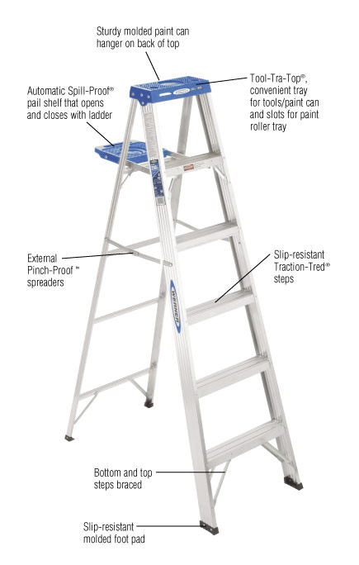 | Common parts of step ladder (example)
Appendix C
Ladder Examples (Page 2 of 3)

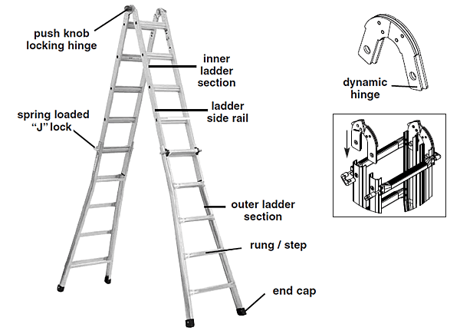 | Common parts of articulated / combination ladder (example)
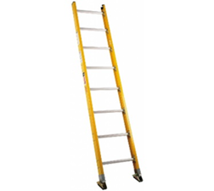 | Single Ladder / Straight Ladder
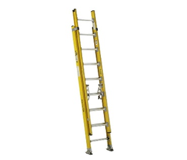 | Extension Ladder
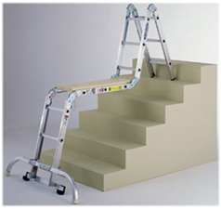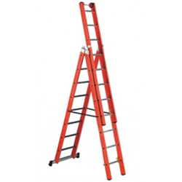  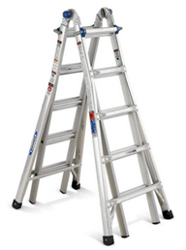 | Articulated / Combination Ladder
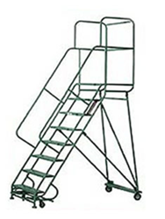 | Mobile Ladder Stand

Appendix C
Ladder Examples (Page 3 of 3)

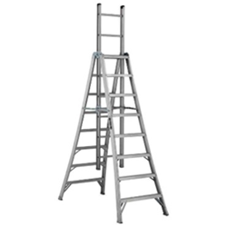 | Extension Trestle Ladder
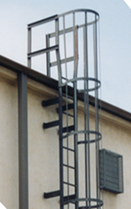 | Fixed Ladder
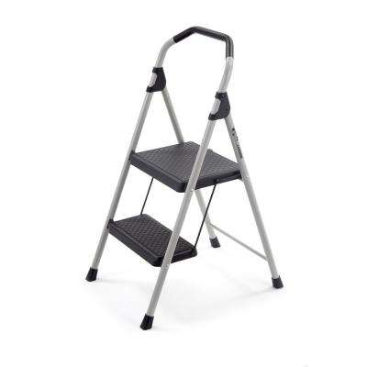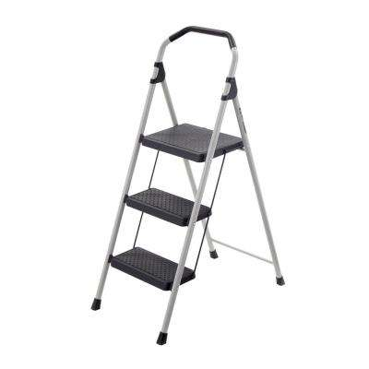 | Step Stool

Appendix D - Student (Unpaid) Ladder Safety Awareness

Ladders are a potential source of workplace injuries. Most of these incidents can be prevented when proper safety precautions are implemented.

- Ladders must be used in accordance with manufacturer’s instructions.
- Users must inspect the ladder prior to using it. If the ladder is damaged, it must be removed from service and tagged until repaired or discarded.
3.) Ladders must have all manufacturer’s labels legible.
4.) Ladders must be faced when ascending and descending.
5.) Users must maintain grasp of the ladder with at least one hand when ascending and descending (three points of contact).
6.) Users may not carry items that could cause a loss of balance while ascending and descending.
- A tool belt, back pack, etc., must be used to carry tools, equipment and materials when necessary.
7.) When ascending, descending or working from a ladder the body must be near the middle of the rungs to prevent accidental displacement.
8.) Ladders must not be loaded beyond their maximum intended load as found on the label.
- Maximum intended load is the weight of the employee, tools, equipment and materials that are carried.
- When using a wooden ladder attention should be paid to the weight limit (typically have lower weight limits).
9.) Ladders are only to be used on stable and level surfaces unless they are secured or stabilized to prevent accidental displacement.
10.) Ladders must not be placed on other objects such as boxes, barrels, scaffolds, or other unstable bases in an effort to achieve additional height.
11.) Ladders are not to be moved, shifted, or extended during use.
12.) Ladders placed in locations such as passageways, doorways, or driveways, where they could be displaced by other activities or traffic must be;
- Secured to prevent accidental displacement, or
- Guarded by a temporary barricade, such as a row of traffic cones or caution tape, to keep the activities or traffic away from the ladder.
13.) Ladders placed on slippery surfaces must be secured and stabilized to prevent accidental displacement.
14.) The top of a non-self-supporting ladder must be placed so that both side rails are supported, unless the ladder is equipped with a single support attachment.
15.) Portable ladders used to gain access to an upper landing surface must have rails that extend at least three feet above the upper landing surface.
16.) Ladders and ladder sections must not be tied or fastened together to provide added length unless they are specifically designed by the manufacturer for such use.
17.) Ladders must not be accessed from the side unless the ladder is secured from accidental displacement.
18.) Prior to climbing, users should look overhead for possible obstructions.
19.) Ladders must be non-conductive when performing electrical tasks and placed at least 10 feet from overhead lines.

Appendix E – Step Stool Safety Awareness
(Page 1 of 2)

Instructions: Reviewing this document is required for employees whose only ladder use involves using step stools such as these types pictured below:

Common examples of step stools:
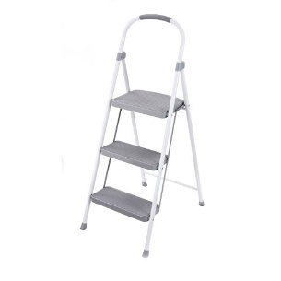

Reviewing this document is not required if only using these types of step stools:
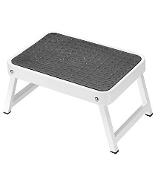

Ladders are a potential source of workplace injuries. Most of these incidents can be prevented when proper safety precautions are implemented.

Proper Use
Step stools are intended for use by one person.
A step stool requires level ground support for all four of its side rails.
A step stool must not be used unless its base is spread fully open and the spreaders are locked. Step stools are not to be used as single ladders or in the partially open position.
In order to prevent tipping over sideways due to over-reaching, the user must climb or work with the body near the middle of the steps or top cap. The step stool should be set up close to the work. Never attempt to move the step stool without first descending, relocating the step stool, and then re-climbing. Do not attempt to mount the step stool from the side or step from one ladder or step stool to another unless the step stool is secured against sideways motion.

Appendix E – Step Stool Safety Awareness
(Page 2 of 2)

When ascending or descending the step stool, users must always face the step stool.
The braces on the rear of a step stool are not intended for climbing or standing and must not be used for that purpose.
The anti-slip feet at the bottom of the step stool side rails must be present and in good condition prior to using. The step stool must not be used on ice, snow or slippery surfaces unless suitable means to prevent slipping is employed.
A step stool must never be placed upon other objects such as boxes, barrels, scaffolds, or other unstable bases in an effort to obtain additional height.
Do not wear sandals, flip flops, or footwear with leather / smooth soles. Clean mud or other slippery substances off of shoes before climbing.

Proper Care
A thorough inspection must be made when the step stool is initially purchased and each time it is placed into service. Clean the climbing and gripping surfaces if they have been subjected to oil, grease or slippery materials. Working parts, bolts, rivets, step-to-side rail connections, and the condition of the anti-slip feet (safety shoes) shall be checked. If structural damage, missing parts, or any other hazardous defect is found, the step stool must not be placed into service and discarded.
A step stool exposed to excessive heat, as in the case of fire, may have reduced strength. Similarly, step stool exposed to corrosive substances such as acids or alkali materials may experience chemical corrosion and a resulting reduction in strength. Remove these step stool from service.
Step stool with bent or broken side rails must not be placed into service.
Do not store other materials on the step stool while it is in storage.
In the event a step stool is discarded, it must be destroyed in such a manner as to render it useless. Another person must not be afforded the opportunity to use a step stool that has been deemed unsafe.

Information retrieved from American Ladder Institute.org

Version No. | Doc. No. | Revision Summary | Issued Date | Revision Originator
1 | EHS-0033 | Original | 07-31-18 | TC
2 | EHS-0033 | Updated section 13.0 (Contractors) | 3-1-19 | TC

