Multimeter – Safe Use Requirements Guide
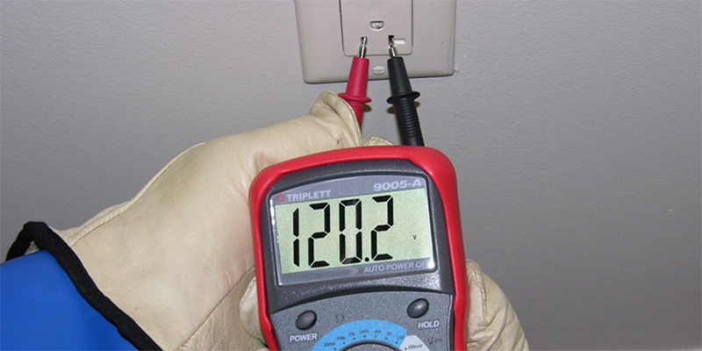

Introduction:
There is an increased risk of arc flash and shock hazards when utilizing a multimeter to conduct electrical testing. The requirements listed in this document will help reduce risk of injury/fire/property damage.
Shock hazards can occur if the meter and test leads are not properly maintained and utilized.
Arc flash hazards can occur if the meter is not properly rated for the voltage, if it is exposed to transient voltages (i.e. a voltage spike) outside its operating limits, and if the meter has defective parts/components.
Scope:
These requirements apply to all PSU locations except the Hershey Medical Center and the College of Medicine.
These requirements pertain to multimeter usage on voltages at or above 50 Volts.
Manufacturer’s Instructions:
Multimeters shall be used in accordance with any instructions provided by the manufacturer.
Properly Rated (for the work environment/location):
Multimeters and their accessories (test probes, flexible clamps, etc.) must be designed for the environment in which they will be used. Example scenario: A test instrument will be used in a hazardous location. The location has flammability/explosion hazards based on the chemicals/processes conducted there. An intrinsically safe multimeter must be used to prevent a fire/explosion during multimeter use.
Refer to the manufacturers documentation to determine if your multimeter is properly rated for the hazardous environment it is used in, commonly referred to as “intrinsically safe”.

Properly Rated (for the category of work, i.e. CAT Rating, and voltage):
The "CAT" rating indicates the multimeters ability to withstand transient overvoltage conditions that could destroy the meter and injure personnel.
For example, a multimeter may be a CAT III-600 V and rated for transient voltages up to 6000 volts. However, another multimeter may be a CAT IV-300 V (higher CAT rating than the example above) but only rated for transient voltages up to 4000 volts.
The following two points must be clarified in order to ensure a multimeter is properly rated for a given task:
1) The nominal system voltage of the equipment must be identified. This is the voltage class assigned to systems and equipment, which can be found on nameplates and drawings. Typical nominal voltages are 120/240, 208Y/120 and 480Y/277.
2) The type of equipment that the multimeter will be used on:
The four CAT ratings are as follows:
a) CAT I - Electronic Equipment.
This category is for measurements of voltages from specially protected secondary circuits. Voltage measurements include signal levels, special equipment, limited- energy parts of equipment, circuits powered by regulated low-voltage sources, and electronics.
b) CAT II – Single-phase receptacle level.
This is sufficient for a receptacle outlet circuit or plug-in loads. This would also include measurements performed on household appliances, portable tools, and similar modules.
c) CAT III – Inside distribution (feeders and branch circuits)
Distribution wiring is qualified for this group, including “mains” bus, feeders, and branch circuits. Also, permanently installed or “hard-wired” loads and distribution boards. Other examples are higher voltage wiring, including power cables, bus bars, junction boxes, switches, and stationary motors with permanent connections to fixed installations.
d) CAT IV – Three-phase utility connections and outside conductor. This is “origin of installation” or utility level applications such as any outside cable run.

CAT multimeter label example:
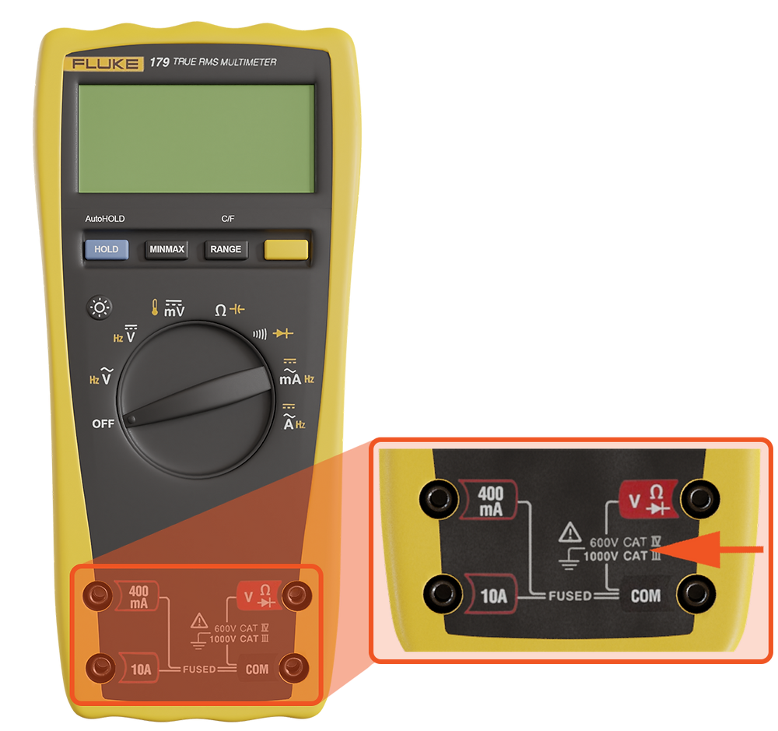

An example of what can happen if an improperly rated multimeter is used (as well as lack of PPE):
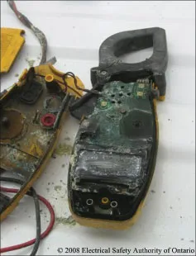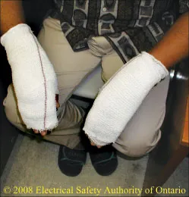
Nationally Recognized Testing Laboratory (NRTL):
Multimeters must be listed by a Nationally Recognized Testing Laboratory (NRTL) and properly labeled with the NRTL's mark. OSHA lists which NRTLs have been approved to test and verify that multimeters meet consensus-based standards.
This testing reasonably assures that products are safe for use. Once the equipment meets the NRTL’s testing criteria, the tool can be labeled with the NRTL's recognized mark. Any multimeter without such a label must not be used.
Among the most common testing laboratory marks found on multimeters are Underwriters Laboratories Inc. (UL), Canadian Standards Association (CSA), and TÜV Rheinland (TÜV).
Current list of NRTL’s:
https://www.osha.gov/nationally-recognized-testing-laboratory-program/current-list-of-nrtls
Visual Inspection:
Conduct a visual inspection of the meter before each use.
The visual inspection must include not only the test tool itself, but all associated test leads, cables, power cords, probes, and connectors. Look for any obvious external defects, cracking, discoloration, fading, fraying, and confirm that there is a good/secure connection when plugged into the multimeter.
One inspection method is to slowly pull test leads between your fingers as you perform a visual inspection. The fingers can often feel damaged insulation even if you miss seeing it.
Test probes (both voltage and current probes) will have a voltage and category rating.
Do not discount the use of clamps, flex clamps, and test probes for current measurements when it comes to visual inspections. Such devices should be marked with a maximum current rating. They should also have the NRTL label. Many test probes are double insulated and marked with the double insulated symbol.
Never hesitate to remove a tool from service if there is any question about its condition.

Personal Protective Equipment (PPE):
When using a multimeter on voltages of 50 Volts or more the following PPE must be worn, at a minimum:
1) Safety glasses
2) Rubber insulating gloves
3) Leather gloves worn over the insulating rubber gloves
Class Designation of Glove or Sleeve | Maximum ac Use Voltage (volts) | Maximum dc Use Voltage (volts) | Minimum Distance Between Gauntlet of Rubber Insulating Glove and Cuff of Leather Glove
00 | 500 | 750 | 0.5 inch
0 | 1,000 | 1,500 | 0.5 inch
1 | 7,500 | 11,250 | 1 inch
2 | 17,000 | 25,500 | 2 inches
3 | 26,500 | 39,750 | 3 inches
4 | 36,000 | 54,000 | 4 inches
Note: Heavy duty leather gloves are made entirely of leather with minimum thickness of 0.03 inches (0.7 mm) and are unlined or lined with nonflammable, non-melting fabrics.
Note: Per the NFPA 70E standard as well as the PSU Energized Electrical Safety Program requirements, rubber insulating gloves must be replaced or sent away to a 3rd party for testing to ensure they still possess electrical insulating properties EVERY 6 MONTHS.
Additional PPE is likely to be necessary based on the equipment/task/voltage. Typically, the trigger for additional PPE is when working on a hard-wired piece of equipment and/or working on building electrical equipment (i.e. circuit breaker panels, disconnect boxes). Contact your Unit’s/Campuses’ Safety Officer or EHS for more information.
Link to the PSU Energized Electrical Safety Program: https://ehs.psu.edu/energized-electrical-safety/requirements-guidelines
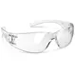
Ohm/Continuity Probe Test
This test ensures that the probes are in good working condition.
If doing this test using the Ohm setting ("Ω" symbol): When the probe tips are not touching each other, the meter will read “OL”. When touching the probe tips together the reading should be near .1 (Refer to the owner manual for proper Ohm range). Higher readings indicate that the probes need replaced.
https://www.youtube.com/watch?v=9C9G5aBpaYY Example of an Ohm probe test (see the first 1 minute and 10 seconds of the video).
If doing this test using the Continuity setting: When the probe tips are not touching each other, the meter will read “OL”. When touching the probes together the reading should be near “0" (Refer to the owner manual for proper continuity range) AND most meters will also make a sound which audibly signifies that the meter probes are in good working order. Higher readings/ no sound indicate that the probes need replaced.
https://www.youtube.com/watch?v=5G622WDZaHg Example of a Continuity probe test (actual test starts at the 1 minute 20 second mark and goes to the 1 minute 50 second mark).

The “Live-Dead-Live” - Multimeter Test:
A multimeter that fails to operate properly could result in a catastrophic accident. Therefore, it is vital to properly perform the "Live-Dead-Live" test method to ensure the meter is working correctly if the task requires verification of zero voltage (i.e. after performing lockout/tagout).
STEP 1 – “LIVE”, wearing proper PPE, turn the function switch to "voltage" and test for voltage on a known energized source or by using an electronic proving unit (purchased separately).
STEP 2 – “DEAD”, test the circuit/conductors that are presumed to be de-energized by measuring phase-to-phase and phase-to-ground across all phases. Zero voltage must be indicated.
STEP 3 – “LIVE”, REPEAT step 1.
Always verify proper multimeter operation!

Storage:
Store the multimeter in a dry, safe place without the potential risk of damage or impact.
A multimeter commonly arrives with a storage case that keeps all the attachments in one place and protects delicate components from physical damage.
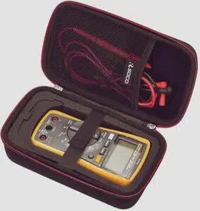
If the multimeter is stored for an extended period, keep in mind to take out the batteries to prevent them from draining and corroding.
If the leads are tightly intertwined for an extended period some internal breaks are more likely to occur.

