Laser Safety Standard Operational Procedure (SOP) TEMPLATE

**INSTRUCTIONS: PLEASE DELETE RED TEXT BEFORE SUBMITTING**
- Red text is designed as an example. Please do not copy word-for-word unless it perfectly encapsulates your actual procedures and control measures.
- Fill out all of the information that you can
  - Sections labeled with a Roman Numeral are required
  - If a sub-section cannot be completed, writing “N/A” or deleting the section are both acceptable
- Feel free to add additional sections if the information is important to the operation and safety of your laser.
- Please create a unique SOP for each laser on your permit
  - Duplicate lasers do not require unique SOPs
  - Lasers that are connected in a system and will never be separated can be included on the same SOP

- Introduction
  - Laser location (Including room number and building name)

  - Diagram of Room (Insert the schematic diagram of your laser lab)

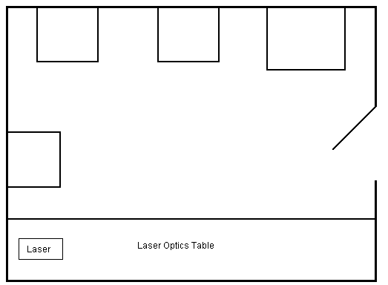

  - Description of Laser
    - Serial number
    - Model number
    - Manufacturer
    - Class
    - Lasing medium
    - Divergence
    - Aperture diameter
    - Pulse length
    - Repetition rate
    - Maximum output

  - Application of the laser (Brief summary of the laser application)

- Hazards

  - Beam hazards (List all potential beam hazards, such as direct beam, reflection, or scattering beam)

  - Non-beam Hazards (List all potential non-beam hazards, such as electrical, fire, explosion, compressed or toxic gas, dye and solvents, LGAC, etc.)

- Controls

  - Access controls – ( Example: The door to the room should be kept locked and warning sign displayed

  - Beam controls – (Example: Power supply is key locked, and beam shutter on laser head

  - Electrical controls on High Voltage – circuit breaker

  - Eye protection types – goggles with OD of x at wavelength of xxx nm

  - Other controls needed – such as beam block, curtains, et al.

- Operating Procedures

  - Initial preparation of laboratory -
    - Closed door will be locked
    - Warning sign on door “Laser in Operation”
    - Identification of all personnel present

  - Personnel protection requirement acknowledged by persons present

  - Target area – Enclosed

  - Detailed step by step operation procedures for daily laser operation

  - Detailed step by step laser shutdown procedures

  - Special procedures:

    - Emergency procedures –
      - For a life-threatening emergency such as electrical shock, fire, etc., dial 911 for emergency response. Contact Supervisor at xxx-xxx-xxxx and EHS at 814-865-6391. Inform EHS that you need to contact the Laser Safety Officer immediately.
      - Non- life-threatening emergencies notify your supervisor and EHS. The appropriate medical attention should be sought if warranted by the supervisor, or EHS, for the persons exposed to the hazard.
      - EHS will begin an investigation as to the circumstances of the event. The system in question shall remain out of service pending the results of the investigation and completion of any corrective actions, if needed. EHS Laser Safety Officer or designee may only return the system to service following approval.
      - Maintenance will lock-out-tag-out the equipment.

    - Alignment procedures – Only experienced personnel will be involved with alignment of the laser.
      - All participants and observers must wear safety glasses.
      - Initial alignment will be performed with a low power (< 1mW) He-Ne laser.
      - Final fine adjustment will be with main laser operating at low power (< 5mW). Only when alignment is accomplished will laser power be increased to maximum

- Training

  - Environmental Health & Safety Training - Prior to beginning work with any lasers Supervisor and users of lasers shall complete the fundamental laser safety training class offered by EHS online. The training will consist of the following general topics: Laser Fundamentals, Laser Hazards, Non-beam Hazards, Laser Accidents, Control Measures, and Elements of PSU’s Laser Safety Program.

  - Specific training for laser use – The Supervisor shall provide training to users in the operating and safety procedures of individual laser systems. All users will sign the Laser Specific Training Documentation Form after completing this training.

  - Maintenance and repair training if applicable – N/A (manufacturer will do any maintenance or repairs)

- Responsibilities

  - Supervisor for normal operations - Supervisors are responsible for the safe operation and maintenance of the lasers and shall provide training to users in the operating and safety procedures of individual laser systems.

  - Emergency coordinator - Following-up on reports of unsafe conditions, ensuring work with the laser is suspended until the unsafe conditions are rectified, and completing and documenting the required inspections, that include but are not limited to, laser specific information, administrative controls, and engineering controls.

  - Operators and other personnel – Are required to complete the laser safety training provided by EHS before beginning work with lasers, to follow written operating procedures, to perform all work in a safe manner and use approved personal protective equipment. Users are also responsible for reporting to the supervisor any unusual or unsafe condition they discover with the laser, and for suspending work with that laser until the unsafe condition is rectified. The user is responsible for immediately informing the supervisor in the event of any exposure to the laser

- Miscellaneous

  - Visitor regulations at site – No unsupervised visitors permitted

