Laboratory and Research Safety Self-Inspection
Guidance Document

Background: The self-inspection process is an opportunity for laboratory and research groups (including teaching labs) to assess, on their own, how well they are meeting various safety regulations, requirements, and policies. Answering ‘NO’ to any question identifies an area that may require corrective actions. This document is a guide for additional information, answers some frequently asked questions, and provides guidance on where to find many of the associated forms.

Q) Who is required to do a “Laboratory and Research Safety Self Inspection”?
  - All laboratory and research groups, including teaching labs, at Penn State that work with biological, chemical, or radiological materials, or reactive processes must follow SY43: Laboratory and Research Safety Plan (https://policy.psu.edu/policies/sy43).
  - This includes Engineering laboratories that work with any biological, chemical, or radiological material, including but not limited to lubricants, paints, and cleaning chemicals.
  - These groups are required to complete the annual self-inspection as part of the overarching Plan.

Q) What if my lab has only computers?
  - If your research area does not include the use of biological, chemical, or radiological materials, or reactive processes, the self-inspection is not required. However, you may still want to take some time to review your space and make sure of a few things such as:
    - ensuring that extension cords and power strips are not connected in series (daisy chaining),
    - ensuring that electrical cords are in good condition, and
    - checking that aisles and exits are clear and unobstructed.

Q) Why is the N/A box blacked out for some of the question?
- Not applicable, or N/A, is not an option for some questions because they apply to ALL laboratory and research groups that work with biological, chemical, or radiological materials, or reactive processes at Penn State. For example, if you are completing this self-inspection, a Unit Specific Plan and trainings are required, therefore N/A is not an option. However, your research might not include work with compressed gases, where marking N/A is appropriate.

A. Laboratory and Research Safety Plan
- Has a Unit Specific Plan been completed?
  - Every laboratory and research group at Penn State that works with biological, chemical, or radiological materials, or reactive processes is required to prepare a Unit Specific Plan.
  - The Unit Specific Plan is the laboratory-specific portion of the Laboratory and Research Safety Plan, with information that is specific and pertinent to the hazards of particular labs or research groups. It summarizes the hazards associated with that research or teaching, including chemicals, biological agents, radiological hazards, and physical hazards.
  - A blank template can be found here: https://ehs.psu.edu/laboratory-safety/forms.

- Is a paper copy of the Unit Specific Plan readily available in the lab?
  - A copy of the Unit Specific Plan is required to be kept on paper in the lab.
  - A copy of the Unit Specific Plan must be readily available. This means easy to find. Ideally, this should be done by placing it in a labeled binder that is kept “near the door.” Further guidance for what must be kept on paper in the lab, and suggestions for how to organize it, can be found on this page: https://ehs.psu.edu/laboratory-safety/guidelines.
- Has the Unit Specific Plan been reviewed within the last year?
  - As part of the University’s overarching Laboratory and Research Safety Plan, Unit Specific Plans for each lab must be reviewed every year to ensure that they accurately reflect the work being performed.
  - If there are no changes from the previous year, then the original printed copy is sufficient.
  - If there are any changes, they must be reflected in the paper copy stored in the lab.

- Has everyone in the lab signed a new Certification of Agreement page within the past year?
  - While the Unit Specific Plan only needs to be updated and reprinted when there are changes, a new Certification of Agreement page must be signed by every member of the lab, every year.
  - A blank copy of just the Certification of Agreement page can be found towards the bottom of this page: https://ehs.psu.edu/laboratory-safety/forms.

- Are standard operating procedures (SOPs) developed and available for hazardous operations?
  - The OSHA Laboratory Standard (29 CFR 1910.1450) requires that SOPs be developed that are relevant to the work performed to ensure protection of researchers.
  - A blank SOP template can be found here: https://ehs.psu.edu/sops.
  - SOPs in other formats are acceptable as long as they include safety information such as what engineering controls or PPE is required to perform the work safely.

B. Training
- Have all personnel in the lab, including PI, completed Initial Laboratory and Research Safety Training and placed certificates in the Laboratory and Research Safety binder or record storage location?
  - Everyone who works in a lab or supervises people performing research, including the PI, is required to take Initial Laboratory and Research Safety Training.
  - This training has changed over the years and initial training certificates may look different.
  - The current version of initial training can be found by logging into the EHS training webpage and filtering by “Laboratory and Research Safety” (https://ehs.psu.edu/training?combine=&tid=136)
    - for those at University Park “Initial Laboratory and Research Safety Training – University Park”
    - for those at other locations “Initial Laboratory and Research Safety Training – Non-University Park ”
    - These courses be found in the Learning Resource Network (LRN) by searching the titles above.
  - Copies of these training records must be readily available. Ideally, this should be done by placing them in a labeled binder that is kept “near the door.” Further guidance for what must be kept on paper in the lab, and suggestions for how to organize it, can be found on this page: https://ehs.psu.edu/laboratory-safety/guidelines.
  - Other record storage locations are acceptable as long as it is very clear where they are stored and how to access them.
  - Please DO NOT send in copies of your training records with the self-inspection.

- Have all personnel in the lab, including PI, completed Refresher Laboratory and Research Safety training within the past year and placed certificates in the Laboratory and Research Safety binder or record storage location?
  - Everyone who works in a lab or supervises people performing research, including the PI, is required to take the annual Refresher Laboratory and Research Safety Training.
  - This is an annual requirement.
  - This training can be found by logging into the EHS training webpage and filtering by “Laboratory and Research Safety” (https://ehs.psu.edu/training?combine=&tid=136) and clicking on “Laboratory and Research Safety Refresher Training.” This course can now also be found in the Learning Resource Network (LRN) by searching the title above.
  - Copies of these training records must be readily available in the lab. Ideally, this should be done by placing them in a labeled binder that is kept “near the door.” Further guidance for what must be kept on paper in the lab, and suggestions for how to organize it, can be found on this page: https://ehs.psu.edu/laboratory-safety/guidelines.
  - Other record storage locations are acceptable as long as it is very clear where they are stored and how to access them.
  - Please DO NOT send in copies of your training records with the self-inspection.

- Have all personnel been instructed in specific and pertinent safety practices and potential hazards for the lab?
  - Individuals that work with radioisotopes, lasers, X-Ray producing equipment, pesticides, biological materials, or animals may be required to take additional training prior to working with these materials. Most of these trainings can be accessed through the EHS training database. The Office for Research Protections is the resource for biosafety and animal training courses.
  - The Initial and Refresher Laboratory and Research Safety Training courses are general and broad in nature. They are meant to cover a wide breadth of material to cover as many research areas as possible at Penn State. Labs are required to provide additional training to new members of their lab that is more specific and pertinent to the work that will be performed.
  - Training should also be provided as new hazards are introduced or new projects started.
  - Lab specific training can be done in many forms, but ideally should be documented in some manner.

C. Signs
- Is a “Laboratory Information Door Sign” completed with up to date information and posted outside the lab?
  - A blank template of the “Laboratory Information Door Sign” can be found on this page: https://ehs.psu.edu/laboratory-safety/forms.
  - The information on this door sign should be kept up to date to provide emergency and after-hours responders with pertinent contact information.

- Are special hazard signs in place (e.g., lasers, biohazards, radioactive, etc.)?
  - Research groups that work with hazards such as lasers, BSL-2 agents, and radioisotopes, must make sure that the pertinent hazard sign is posted.

D. General Housekeeping
- Are aisles and exits free from obstructions?
  - Aisles and exits must be free and clear. This means no trip hazards, nothing blocking the path, and wide enough to easily walk through.
  - Actual width requirements for aisles varies based on specifics of each location.
  - Think about having to make a hasty exit in an emergency, and then ensure that nothing will block your path out.
  - Likewise, should your lab require emergency response, we want to ensure that aisles are wide enough to accommodate emergency responders and the equipment they may need.
  - Policy SY36 – Corridor Storage and Use provides some additional information (https://policy.psu.edu/policies/sy36).

- Is food or drink only consumed outside the lab?
  - Food and drink should not be consumed in lab areas. This helps in preventing accidental cross contamination of food and drink.
  - For some research groups, certain regulations explicitly forbid eating or drinking in a laboratory area, including groups that work with radioisotopes.

- Are benches and shelves not overloaded with unused equipment or chemicals?
  - Labs that are cluttered and poorly organized can present a variety of safety hazards and can even be cited for this during regulatory inspections. Research shows that spills and accidents are more likely to occur in cluttered workspaces.
  - Keeping things clean and organized minimizes the potential for accidents and the consequences of accidents that do occur. Beyond day-to-day straightening and cleaning, periodic “lab clean-up days” can help prevent the buildup of hazardous conditions.
  - Ensure that equipment and chemicals that are no longer being used are returned to their proper storage location in the lab.
  - If your lab no longer uses particular chemicals, they should be disposed of as chemical waste.
  - If your lab no longer has use for equipment, talk to your department safety officer about how to dispose of the equipment through Lion Surplus. Groups at Commonwealth Campuses should talk to their Lab Safety Officer.

- Is all storage at least 24” from the ceiling?
  - This question is written for the most conservative set of variables when discussing the minimum required distance between stored items and the ceiling. The actual requirements are somewhat complex.
  - In unsprinklered buildings, storage must be at least 24” from the ceiling.
  - In sprinklered buildings, storage must be at least 18” from the ceiling. Additionally, stored items must never block a sprinkler or the path of water should the sprinkler activate.
    - Never hang anything from a sprinkler head.

- Is only glassware in good condition used (i.e. nothing broken or chipped)?
  - Chipped and broken glassware should not be used. It should be disposed of promptly in an appropriate manner.
  - “Clean” chipped or broken glassware can be placed in a broken glass box for disposal.
  - If it is contaminated with biological material, it should be placed in a biohazard sharps container.
  - If it is contaminated with chemicals, it should be placed in a rigid puncture proof container and handled in the same manner as other chemical waste (discussed in section I: Laboratory Waste).

- Is Bunsen burner/micro burner tubing in good condition, free from cracks and splits?
  - Never use Bunsen burner tubing that has cracks or splits in it. Cracks or splits can allow the gas to escape and cause a fire in an unintended area.
  - If Bunsen burner tubing is cracked or has splits, it must be replaced.

- Are radioactive, biohazardous, and hazardous materials secured from unauthorized removal?
  - Some materials used in research have additional regulations that require them to be secured from removal by those not authorized to use them. Always ensure that these items are properly secured by a method or manner that meets regulatory requirements.
  - For other materials, securing them from inappropriate use or removal is prudent behavior.

- Have all ladders been inspected within the past year, and individuals trained in their proper use and care?
  - The Ladder Safety Program (https://ehs.psu.edu/Ladder-Safety/overview) covers the use of all ladders and stepstools at Penn State.
  - Make sure that anyone who uses a ladder is appropriately trained.
  - Ensure that all ladders have been inspected within the past year and the inspection documented on the inspection sticker.
  - Stepstool safety is covered in “Appendix E” (https://ehs.psu.edu/ladder-safety/forms).

E. Personal Protective Equipment (PPE)
- Are safety glasses with side shields worn as required?
  - Eye protection is required to be worn when working with materials that could harm the eyes, including flying particles, molten metal, liquid chemicals, acids, or caustic liquids, chemical gases or vapors, or potentially injurious light radiation.
  - All eye protection must comply with, and be marked with, ANSI Z87.1.
  - Safety glasses should be in good condition, with no scratches, chips, or cracks.
  - Standard eyeglasses, even with side shields, are NOT safety glasses. Prescription safety glasses must meet the same requirements under ANSI Z87.1. For information about how to purchase prescription safety glasses, see “Instructions for Obtaining Prescription Safety Glasses and Safety Shoes” (https://ehs.psu.edu/ppe/resources) or talk to your department safety officer.

- Are chemical splash goggles and face shields worn when appropriate?
  - Eye protection is required to be worn when working with materials that could harm the eyes, including flying particles, molten metal, liquid chemicals, acids, or caustic liquids, chemical gases or vapors, or potentially injurious light radiation.
  - All eye protection must comply with, and be marked with, ANSI Z87.1.
  - If you will be working with items that have a serious risk of eye injury upon exposure, it may be more prudent to wear chemical splash goggles or a face shield to provide better protection.

- Are only closed toe shoes worn in the lab (no sandals or open toe shoes)?
  - Everyone working in a lab must wear closed toe shoes.
  - Wearing closed toe shoes is the simplest way to minimize the damage that may be done if something falls on your feet.
  - “Closed toe shoes” really means that the entire foot should be fully covered. This includes the top of the foot and the heel. Shoes with large perforations in the uppers (such as “croc” style shoes) are not permissible, as they will not prevent spilled chemicals from reaching your foot. Likewise, the back of the foot should be covered too.
  - Open toed shoes, such as sandals, must not be worn in the lab.

- Are gloves selected and worn according to hazard?
  - Not all gloves are created equal. Even gloves that may appear on the surface to be the same, like nitrile gloves, may behave differently under the same conditions. Always make sure that the gloves worn for research activities are appropriate for the materials being handled.
  - Make sure that gloves are in good condition before starting work.
  - Promptly change gloves if holes, cracks, or color changes occur while wearing gloves.
  - Always wash your hands after removing your gloves.

- Is protective clothing selected and worn according to hazard (e.g., lab coats, splash aprons, flame resistant lab coats, etc.)?
  - Much like gloves, not all lab coats are created equal. You should choose a lab coat or other body protection that is appropriate for the hazards you may face.
  - A standard cotton/polyester blend coat provides general protection against some chemicals and splashes.
  - If you will work with anything that produces sparks or flames, or has a chance of catching fire, you should wear a flame resistant (FR) lab coat.
  - When full coverage is not necessary, consider wearing an apron. A splash apron over a lab coat can also provide good protection depending on the work being performed.
  - Some companies now also produce lab coats that provide a higher level of chemical protection (CP). These provide additional protection from chemical splashes while also providing the traditional coverage of a lab coat.

F. Safety Equipment: Showers, Eyewashes, and Fire Extinguishers
- Are showers and eyewashes labeled, accessible, and unobstructed with 30” of clearance?
  - Safety showers and eyewashes should never be obstructed. Ideally, you should be able to find them with your eyes closed in the event of an emergency. Never place anything underneath, near, or around a shower that could block access or functioning of the unit.
  - Ensure that showers and eyewashes have at least 30” of clearance. This means 15” in each direction around the shower and eyewash should have nothing placed or stored there.
  - Also consider the quantity of water that may come out of a shower or eyewash during emergency use and consider what nearby equipment is suitable for getting wet. If it is not safe for equipment to get wet, then it should not be stored near an eyewash or shower.

- Are eyewashes and drench hoses flushed weekly?
  - Eyewashes must be flushed every week. This helps to ensure that it not only functions properly, but also has clean water in it for use. Flushing helps clean out rust, scale deposits, or bacteria that may accumulate. We all know what water can look like after coming from a faucet after not being used for quite some time. Not what you want in your eyes in an emergency!
  - The “Eyewash Inspection Form” can be found on the EHS webpage: https://ehs.psu.edu/laboratory-safety/forms.
  - Inform your departmental safety officer if your eyewash or drench hose does not function properly.

- Are fire extinguishers in designated locations and are these locations labeled (if necessary)?
  - Fire extinguishers must be properly mounted. It is not acceptable to store a fire extinguisher on the floor.
    - At University Park, Office of the Physical Plant is responsible for properly mounting fire extinguishers in designated locations.
    - At other locations, maintenance personnel are responsible for mounting fire extinguishers in designated locations.
  - Fire extinguishers that are not highly visible must have signage so that they can easily be located.

- Are fire extinguishers and pull stations accessible and free from obstructions, with 36” of clearance?
  - Fire extinguishers and fire alarm pull stations should never be blocked in any manner. They must always be kept clear so that they are easily accessible in the event of an emergency.
  - Ensure that fire extinguishers have at least 36” of clearance. This means 18” in each direction around the fire extinguisher should have nothing placed or stored there.

G. Chemical Inventory and Storage
As per SY39: Hazardous Chemical Inventory Management (https://policy.psu.edu/policies/sy39), chemical owners (including laboratory and research groups) are required to enter their chemical inventory into the Chemical Inventory Management System (CHIMS). If your lab has chemicals, these questions must be answered. Likewise, if your lab has chemicals, your lab likely generates chemical waste, which is covered in section I.

- Has chemical inventory been reviewed and updated within the last year in CHIMS?
  - As per SY39: Hazardous Chemical Inventory Management (https://policy.psu.edu/policies/sy39), chemical owners are required to enter their chemical inventory into the Chemical Inventory Management System (CHIMS) and ensure that the inventory is verified and updated at least annually.
  - SY39 contains a list of what type of chemicals must be included in a chemical inventory. The easiest way to determine if a chemical must be entered into the inventory is to see if there are any GHS pictograms on the container or the SDS. If so, then it must be inventoried.
  - CHIMS can be accessed at this page: https://psu.bioraft.com/.

- Are chemicals dated upon receipt?
  - Good chemical hygiene includes writing the date of receipt on all incoming chemical containers. This simple practice can help personnel know how old chemicals are, and for some chemicals, will help determine an appropriate disposal timeline.

- Are all chemicals, such as peroxide formers, within their expiration date?
  - Some chemicals, such as peroxide formers, form dangerous compounds over time in storage. Chemicals like these must not be kept past their expiration date.

- Are all chemical containers, including wash bottles, labeled properly, capped, and in good condition?
  - All chemical containers must be properly labeled with the chemical name and the associated hazard(s).
  - For chemicals in their original bottle, the original label should be maintained. If the label becomes unreadable, affix a new label with the pertinent missing information.
  - When transferring chemicals to another container, such as a working stock bottle or when making solutions, make sure to copy the chemical name over along with the hazards.
  - Full chemical names and hazards should be written out in English.
  - Unknown chemicals pose unpredictable hazards to those who handle the material, and higher costs for disposal. If it is not labeled it will eventually become an unknown.
  - Every container with chemicals must have a secured lid.
  - Chemical containers must be in good condition, not chipped or cracked.
  - Food and beverage containers are NEVER appropriate for chemical storage.

- Is the storage of chemicals on, above, or next to desks avoided?
  - Desks in research areas are not ideal. However, they are a reality in many Penn State research labs. Do not use desk areas, or the areas directly adjacent to desks, to store chemicals.

- Are all hazardous chemicals, including corrosives, solvents, and flammables, stored below "eye level"?
  - Hazardous chemicals should never be stored above “eye level.”
  - “Eye level” is a loose definition, but should aid labs in knowing what is considered “too high” to store hazardous chemicals that may leak.
  - Storing chemicals below eye level reduces the likelihood of accidental splashes to the eyes and face.

- Are chemicals segregated by hazard (organics away from oxidizers, flammables away from oxidizers, acids away from bases)?
  - Never store chemicals in pure alphabetical order.
  - Chemicals should first be segregated based on hazard, and then stored appropriately within that group. Chemical storage groups can include: flammables, volatile poisons, oxidizing acids, organic and mineral acids, liquid bases, liquid oxidizers, non-volatile poisons, reactives/metal hydrides, and dry solids.
  - Take particular care to make sure that incompatible chemicals are not stored near each other. This includes separating flammables from oxidizers, acids from bases, and organics from oxidizers. Inadvertent mixing of these chemicals in an emergency could make the situation worse.

- Is chemical storage kept to a minimum, with only chemicals to be used in upcoming work kept on hand?
  - Ideally, only the chemicals needed for active projects should be kept on hand. Avoid buying in bulk unless absolutely necessary.
  - Spills and accidents are more likely to occur in cluttered workspaces.
  - The information discussed in question 13 is also applicable here. Good general housekeeping is important in chemical storage, where excess materials, especially if not stored properly, can increase the likelihood of accidents and incidents.
  - Minimizing chemical storage also helps decrease the potential of accidentally storing incompatible materials near each other.
  - Cluttered chemical storage areas can also lead researchers to overlook old chemicals that are no longer stable.
  - Properly disposing of unneeded chemicals also frees up storage space for proper storage and segregation of needed chemicals.
  - Chemicals that have begun to hydrate and stick together, have changed from their original color, have oxidized, or are otherwise not in “like new” condition should be handled as chemical waste. A green tag should be affixed and a pick up request submitted.

- Is secondary containment used for elemental mercury use and storage?
  - Anyone performing work with elemental mercury must make sure that it is used and stored in secondary containment.
  - Never clean up a mercury spill by yourself! Always call EHS if a mercury spill occurs, including broken mercury thermometers.

- If more than 10 gallons total of flammable liquids, including waste, are present in the lab, is it stored in approved safety cans or flammable storage cabinets?
  - Building code in the commonwealth of Pennsylvania requires that where flammable liquids are stored, including waste, anything over 10 gallons total must be stored in a flammable storage cabinet or approved safety cans. This includes alcohols, solvents, and other flammable materials.

H. Compressed Gases
- Has inventory of compressed gas cylinders been updated within the last year in CHIMS?
  - By definition, compressed gases are hazardous chemicals. They must be inventoried in CHIMS as discussed in question 29.
  - For labs that go through cylinders regularly, the maximum quantity of compressed gas that can reasonably be anticipated to be on hand should be entered into the system. For example, if your lab regularly has 3 cylinders of compressed nitrogen on hand (one attached to equipment and in use, one “empty” ready for pick up, and one in back up) then the inventory should reflect 3 FULL cylinders. This would reflect the maximum quantity that the lab could have at any one time.

- Are old and/or unused gas cylinders promptly returned to General Stores, the vendor, or submitted for chemical waste pick up?
  - Unused, unneeded, and old gas cylinders should promptly be removed from the lab. If the cylinder was ordered from General Stores, it should be returned that way. If it was ordered directly from a vendor, determine if they will accept the cylinder back, and then arrange to do so. If neither of these paths for disposal is possible or appropriate, submit the cylinder as waste through the chemical waste pick up system: https://psu.chemicalsafety.com/psu/.
  - General Stores and many vendors charge a cylinder rental fee in addition to the charge for the contents. Keeping unneeded cylinders can cost your lab unnecessary fees.

- Are cylinders properly secured with a strap or chain in an upright position?
  - Compressed gas cylinders must be stored in an upright position.
  - Compressed gas cylinders must be strapped or chained in place to prevent them from being knocked over. The strap or chain must be anchored into the wall or securely clamped to a stable surface.

- Are stored cylinders tightly capped and kept to a minimum?
  - When not in use, remove regulators and connections from cylinders, and secure the cap.
  - Only cylinders that are needed for active projects should be kept on hand.

- Are flammable materials stored more than 20’ from oxygen cylinders?
  - Flammable materials and oxygen make a fiery mixture.
  - They must be separated by at least 20’.
  - For equipment or setups that require both oxygen and a flammable gas to be closer to each other than 20’, a suitable fire barrier must be placed in between the secured cylinders.
  - Likewise, other flammable materials, including solvents, must be either stored at least 20’ away from oxygen cylinders, or in a flammable storage cabinet.

- Are regulators, connections, and tubing in good condition?
  - Always ensure that the regulator, connections, and tubing used with compressed gases are in good condition.
  - Likewise, ensure that the items being used are compatible with the contents of the cylinder.
  - Never force a connection!

- Is flammable gas tubing secured and labeled?
  - When using flammable gases, such as hydrogen, ensure that the tubing is secured and well labeled.

- If toxic gases are used, are appropriate leak sensors or alarms in place, regularly checked, and calibrated?
  - Toxic gases include, but are not limited to: anaesthetics, carbon monoxide, ammonia, phosgene, etc.
  - Best practice for labs that use toxic gases is to have sensors or alarms in place. This way if a leak occurs, there is sufficient time to either fix the problem or evacuate the lab before an exposure occurs. This is especially important for gases that have no odor, or that can incapacitate a person at low concentrations.
  - For alarms and sensors to function properly, they must be maintained. Proper maintenance varies by sensor and you should consult the manufacturer’s manual. Some sensors must be tested regularly, calibrated on a specific cycle, and replaced entirely during specific time frames.
  - Some lab groups choose to pay third party vendors to maintain these systems so that they will function as needed should a leak occur.

I. Laboratory Waste
ALL laboratory and research groups, including teaching labs, that generate chemical waste fall under the Laboratory Waste Management Plan, which can be found on this page: https://ehs.psu.edu/chemical-and-hazardous-waste-management/requirementsguidelines. This is colloquially known as “Subpart K” after the EPA regulation that Penn State follows to manage hazardous waste. If your lab is generating chemical waste, then that likely means the questions in section G that cover chemical inventory should also be answered.

- Is a current “Laboratory Satellite Accumulation Area” (SAA) sign hung near waste area?
  - This is a tiny screen shot of the ONLY acceptable SAA sign.
  - 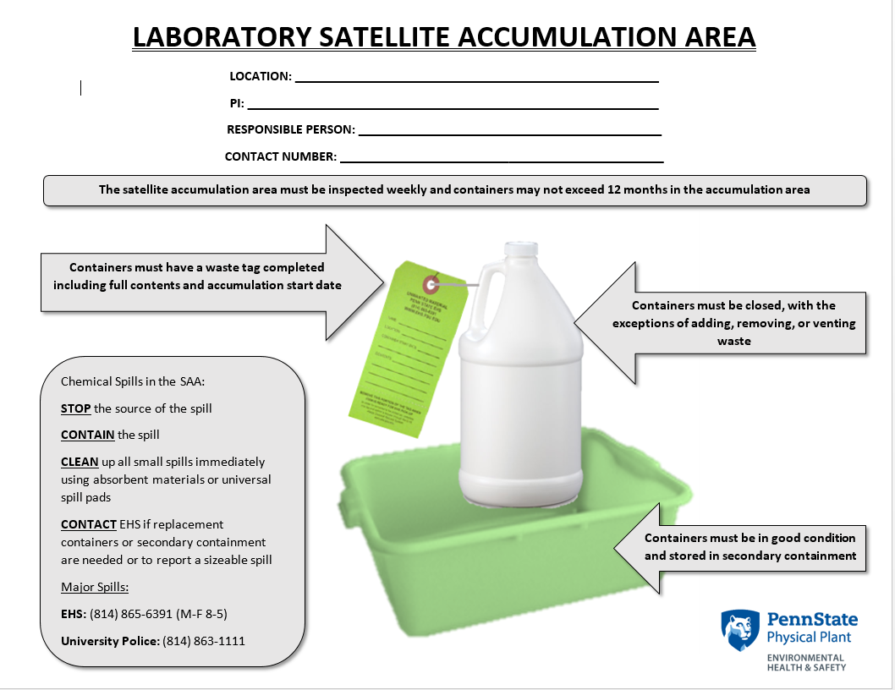
  - You can download a printable version of this sign from this page: https://ehs.psu.edu/laboratory-safety/forms.
  - The old version has a portrait orientation with no pictures or Penn State logo. Old versions should be discarded.

- Do all chemical waste containers have a green tag attached?
  - EVERY container that has ANY chemical waste in it MUST have a green tag attached in some manner.
  - Red tags are not acceptable and lab generated waste will not be picked up if a red tag is used.
  - This is what green tags look like:
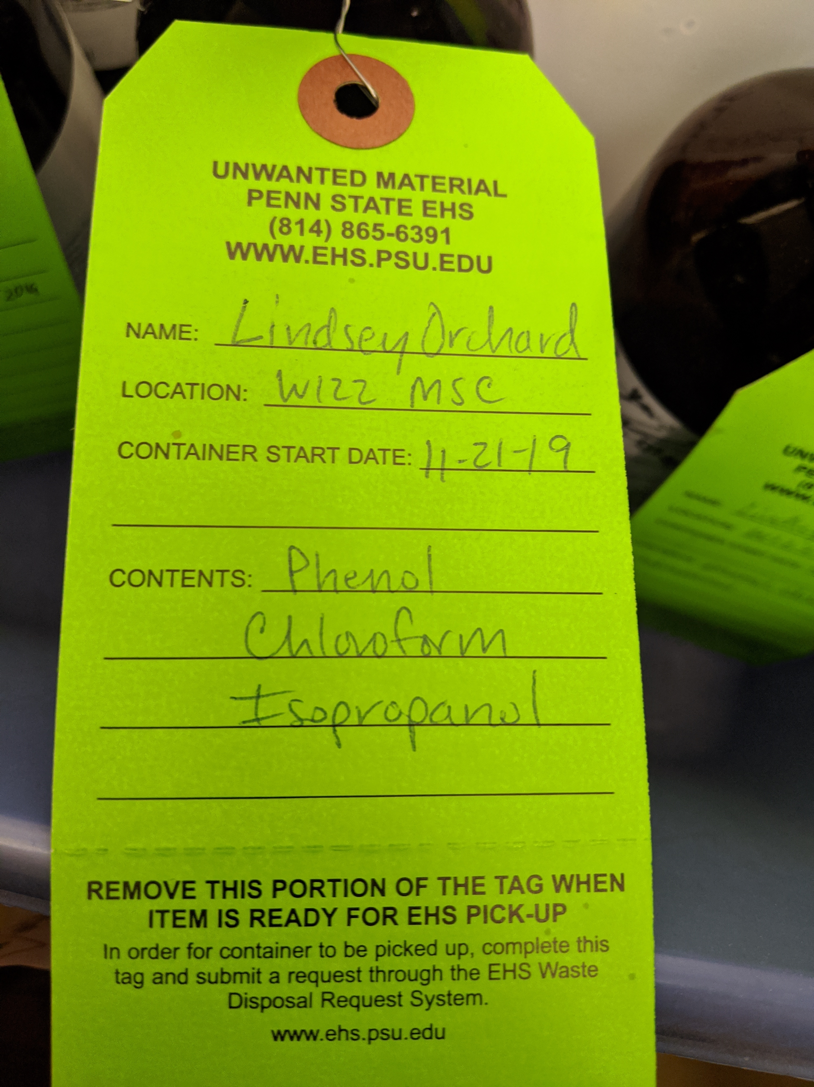
  - If you need additional green tags, contact your department safety officer, or EHS at ehslabsafety@psu.edu to request more. At Commonwealth Campuses, your Lab Safety Officer or Regional Coordinator may be able to provide these to you quicker than requesting them from University Park.

- Are all green tags in use filled out completely with name, location, start date, and container contents sections complete?
  - Every green tag must have the name of the waste generator, the room and building the SAA is in, the first date waste was added to the container, and a list of all the contents of the container.
  - If your chemical waste container has more constituents than will fit on the green tag, additional tags or sheets may be attached. Some labs place preprinted stickers on their tags, others attach a typed list. The contents must be listed AND attached AND legible.
  - Abbreviations are not appropriate on green waste tags, the full chemical name must be written out so proper hazard identification can be performed when the waste is picked up.

- Are SAAs inspected weekly and documentation maintained?
  - SAAs are required to be inspected every week there is waste in the SAA.
  - This weekly inspection includes writing the date of the inspection, ensuring that everything is labeled properly (green tags attached and completed), segregated properly (just like stock chemicals are segregated based on compatibility), no containers are leaking, all containers are in secondary containment, waste is less than 11 months old, and that there is not more than 55 gallons of waste in the SAA. The person doing the inspection should then sign for that row.
  - SAA weekly inspection documentation must be maintained for 3 years.
  - If ALL the waste gets pick up and NOTHING remains in the SAA, you can write “no waste” and stop inspecting. But as soon as waste is back in the area, weekly inspections must resume.

- Is the current SAA weekly inspection sheet being used to document weekly inspections?
  - This is a tiny screen shot of the weekly inspection sheet.
  - This is the only acceptable version of the weekly inspection sheet.
  - You can download the form from this page: https://ehs.psu.edu/laboratory-safety/forms.

- Is all waste in the SAA less than 11 months old?
  - Under Subpart K, the EPA dictates that labs shall not keep waste for “too long.” The regulation defines “too long” as a year.
  - Labs should submit their waste for pick up no later than 11 months after the date on the tag to ensure there is sufficient time to arrange for pick up.
  - The current version of the inspection sheet includes a column for “waste has not exceeded 11 months in SAA” to aid labs in keeping track of how old their waste is.

- Is all waste stored in secondary containment?
  - ALL chemical waste is required to be stored in secondary containment.
  - EHS distributes secondary containment. At University Park, if you know your lab will need more and are submitting a pick up request, use the notes section to request additional containment. Otherwise, the request can be emailed to ehslabsafety@psu.edu and they will be delivered to you.
  - Extra secondary containment is generally NOT stored in the EHS office.
  - The weekly inspection sheet includes a column to remind labs that all waste must be stored in secondary containment.

- Is total volume of all waste less than 55 gallons?
  - Labs cannot store more than 55 gallons of waste total. For many labs, this is not a problem because they do not generate a large volume of waste. For labs that do generate a large volume of waste, submitting regular pick up requests can help keep the volume below the regulatory limit.
  - The weekly inspection sheet includes a column to remind labs of the 55 gallon limit.

- Are only red/orange biohazard labeled bags used for regulated medical (biohazard) waste?
  - Red or orange bags, with the biohazard symbol, are required for regulated medical waste.
  - Regulations from the Commonwealth of Pennsylvania dictate that if regulated medical waste is bagged, which includes much of the biohazardous waste produced at Penn State, the bags must be red, red-orange, or orange.
  - Clear or white biohazard bags do not meet this regulatory requirement.

- Are sharps, including needles, razor blades, scalpel blades, etc., disposed of in rigid puncture proof containers?
  - Sharps include any item that can puncture or cut skin, including needles, razor blades, scalpel blades, broken glass, etc.
  - NEVER discard of sharps in the regular trash.
  - Sharps must be disposed of in a rigid puncture proof container with a tightly closing lid.
  - For labs that generate sharps waste contaminated with biological material, the sharps should be placed into a biohazardous sharps container. Biologically contaminated broken glass should also be placed into a biohazardous sharps containers.
  - For labs that generate sharps waste contaminated with chemicals, these should be placed in a rigid puncture proof container, green tagged, and handled like all other chemical waste. Chemically contaminated broken glass should also be discarded this way.
  - Labs are generally responsible for purchasing their own sharps containers.
  - NEVER overfill a sharps disposal container. Biohazardous sharps containers have a fill line printed on them. It is NOT the top of the container. For other container types, 2/3 is considered “full.”
  - Uncontaminated broken glass should go into “broken glass disposal boxes,” which have a thick plastic bag inside a thick cardboard or plastic box.

J. Laboratory Appliances
- Are only "explosion proof" or "flammable storage" refrigerators/freezers used to store flammables?
  - Flammable materials with a flash point less than 100 °F (37.8 °C) that require cold storage must be stored in a refrigerator or freezer that is designed and rated to store these types of materials. These are usually sold as “explosion proof” or “flammable storage” units.
  - These units are designed to have a “spark-free” interior, with electrical components, temperature controller, and other wiring external to the unit.
  - Many solvents and alcohols should never be stored in a standard refrigerator or freezer.

- Are refrigerators/freezers that are not "explosion proof" or "flammable storage" clearly labeled "NO FLAMMABLES ALLOWED"?
  - Standard refrigerators or freezers that are not designed for flammables storage must be labeled “NO FLAMMABLES ALLOWED” and used accordingly.
  - The internal wiring and mechanisms in these units can provide enough of a spark for flammable materials to catch fire or explode.

- Are refrigerators/freezers labeled for "CHEMICAL/LABORATORY USE ONLY" or "FOOD USE ONLY" and used accordingly?
  - Never store food or beverages in the same refrigerator or freezer that is also used for laboratory items such as chemicals or biological agents.
  - Units that contain consumable items such as food or beverages must be labeled “FOOD USE ONLY.”
  - Likewise, refrigerators or freezers used to store laboratory or research materials must be labeled “CHEMICAL/LABORATORY USE ONLY.”

- Are microwaves labeled for "CHEMICAL/LABORATORY USE ONLY" or "FOOD USE ONLY" and used accordingly?
  - Never use the same microwave for food or beverages that is also used for laboratory items such as chemicals or biological agents.
  - Microwaves that will be used with consumable items such as food or beverages must be labeled “FOOD USE ONLY.”
  - Likewise, microwaves used for laboratory or research materials must be labeled “CHEMICAL/LABORATORY USE ONLY.”

- Are the interiors of appliances in good condition and free of spills or contamination?
  - Always ensure that spills are promptly cleaned up, including those found inside of appliances.
  - Regularly check the inside of laboratory equipment to ensure that it is in good condition.
  - This can also include regularly ensuring that refrigerators or freezers are cooling to necessary temperatures.

K. Laboratory Hoods and Local Exhaust
- Are chemical fume hoods working properly?
  - There are many different types of chemical fume hoods in use at Penn State. Labs should be familiar with the specifics of the hoods in their space.
  - Check the following items to ensure that your hood is functioning:
    - the sash opens and closes as designed (can be raised and lower, can move left to right)
    - the light works
    - the alarm works
    - the glass is intact, including no chips or cracks
    - there is air flow
  - Problems should be reported to your facility coordinator or safety officer.

- Are chemical fume hoods free of chemical storage and excess equipment?
  - Storing chemical containers and equipment in a chemical fume hood impairs the performance of the hood.
  - In order to function properly, the vents, grates, and baffles in a chemical fume hood should never be blocked.
  - Ensure that only necessary equipment is in the fume hood. They are not designed for storage. When finished with chemicals and equipment, return them to their proper storage location in the lab.

- Are hood sashes closed when not accessing?
  - Closing a fume hood sash when the unit is not in use is both a safety measure and a means of saving energy.
  - Fume hood sashes should be closed when not accessing so that if an unplanned reaction occurs, the sash can provide some extra protection.
  - Fume hoods consume a large amount of energy to maintain air flow. Closing the sash when not in use minimizes the amount of energy needed to maintain this flow.

- Have biological safety cabinets (BSCs) been tested and certified within the last year?
  - Biological safety cabinets must be tested and certified every year.
  - Penn State does not perform this service. A list of vendors capable of performing testing and certification can be found on this page: https://ehs.psu.edu/biosafety/biosafety-resources.

- Has the use of open flames (Bunsen burners, alcohol lamps, butane torches, etc.) in BSCs been eliminated?
  - The use of open flame devices, including Bunsen burners, alcohol lamps, and butane torches, will void the warranty of many BSCs.
  - Bunsen burners in particular are hazardous to use in a BSC because of the potential for gas build up inside the cabinet. The use of Bunsen burners has led to fires and explosions in BSCs at a number of research institutions.
  - The “Bunsen burners and biosafety cabinets” document provides some alternatives (https://ehs.psu.edu/laboratory-safety/resources).

L. Electrical Safety
- Is the lab free from exposed wiring and frayed cords?
  - Always ensure that electrical cords are in good condition. This means making sure that no wiring is exposed, and that frayed cords are dealt with promptly.
  - This can be a problem particularly where cords might regularly be bent, such as where they exit equipment and the plug end.
  - Exposed wiring and frayed cords both present a fire hazard and a potential source of electrical shock.

- Are extension cords for temporary use only and not overloaded?
  - Inappropriate use of extension cords can present a fire hazard.
  - They should only be used on a temporary basis (less than 90 days).
  - The length and size of extension cords should be determined by the amount of amperage that will be drawn by the items being plugged into it.

- Is the practice of connecting extension cords and power strips is series (daisy chaining) avoided?
  - Never daisy chain extension cords and/or power strips. This means plugging together two or more extension cords, or plugging an extension cord into a power strip.
  - This presents an electric hazard, which can lead to fire and/or equipment damage.
  - They are not designed to be used in this manner.

- Are electrical panels free from obstruction, with 36” of clearance?
  - Just like other safety equipment (fire extinguishers, eyewashes, safety showers), electrical panels must be kept clear and free from obstruction.
  - Nothing should be placed directly in front of electrical panels or block access to the panel door.
  - By building code, panels must have 36” of clearance so that they can easily be accessed.

M. Electrical Equipment or Apparatus Used for Research
- Has a risk assessment been performed and documented for each piece of “lab built” equipment according to the Safety Risk Assessment for Lab Electrical Equipment program?
  - This program only applies to “home made” “lab built” equipment. If equipment is purchased and used as is, “plug and play,” then this program does not apply.
  - The assessment form, entitled “Safety Risk Assessment for Lab Electrical Equipment FORM BLANK,” should be completed for each piece of “lab built” equipment. A blank template can be found on this page: https://ehs.psu.edu/laboratory-safety/guidelines.
  - A copy of this form should be kept in the Lab Safety binder in the lab.

- Has training been performed for those individuals who utilize the equipment?
  - Anyone who uses “lab built” or “home made” equipment, as documented in question 70, must be trained in appropriate usage of the equipment. Further guidance about training requirements is provided on the webpage listed above in the document titled “PSU Safety Risk Assessment for Lab Electrical Equipment document.”

- Has the equipment been modified in the last year? If so, has the risk assessment been updated?
  - If “lab built” equipment has been modified within the past year, review the risk assessment, and update it if necessary.

N. Vacuum Equipment
- Are vacuum pump belt guards in place?
  - All vacuum pump belts must be guarded.
  - Equipment like vacuum pumps cannot have exposed moving parts that are pinch points or could catch loose clothing, hair, etc.
  - Many modern vacuum pumps are sold with these guards already in place. Ensure that the guard is installed as designed.
  - On older vacuum pumps, or vacuum pumps sold without a guard, your lab is responsible for purchasing or having a guard fabricated to cover the belt.

- Is all glassware attached to vacuum pumps wrapped or shielded?
  - All glassware that is attached to a vacuum pump must be wrapped or shielded. This will minimize or prevent the spread of shrapnel should the vessel implode.
  - Appropriate wrapping can include plastic mesh sleeves purchased from major scientific supply companies or sturdy fabric tape.
  - Appropriate shielding means that the glassware is enclosed on all sides with a shatterproof material. This can include a fume hood with the sash fully closed.

O. Machine Shop Safety
- Have all personnel in the lab who use machine shop type tools (e.g. belt sanders, miter saws, band saws, drill presses, lathes, milling machines, laser cutters, etc.) received training? Is the training documented?
  - Many research groups and labs have machine shop type equipment, but do not count as machine shops. Groups with miscellaneous equipment like this generally fall under Section 9 of the Machine Shop Safety Program (https://ehs.psu.edu/machine-shop-safety/requirements-guidelines).
  - Appendices C and D of the Machine Shop Safety Program covers training requirements for this program.

- Is machine guarding in good condition and working properly?
  - Section 7 and the “Machine Guarding Reference Guide” (Appendix E) of the Machine Shop Safety Program (https://ehs.psu.edu/machine-shop-safety/requirements-guidelines) discuss machine guarding requirements at Penn State.
  - Guards must be in good condition (not cracked, chipped, etc.) and function properly.

P. Ultraviolet Light
- Has an SOP been written for the use of ultraviolet light emitting devices?
  - An SOP should be written and available for all laboratory members to use describing what ultraviolet light emitting devices are used in the laboratory and how to safely use those devices. This SOP should include the use of any pertinent engineering controls and the correct PPE to wear to prevent exposure to UV light.

- Has appropriate PPE been purchased, and is it being used, for work with ultraviolet light?
  - For work that includes potential exposure to ultraviolet (UV light), the use of appropriate PPE will protect your skin, face, and eyes from burns.
  - Protect the skin on your wrists and neck by wearing a lab coat (or long sleeves) fully buttoned up.
  - Wear gloves that fully cover your wrists.
  - If there is the potential to expose your face to UV light, wear a face shield. Most standard face shields made of polycarbonate will protect the wearer from short term exposure to UV light. If your research involves longer term exposure to UV, wear a face shield with the appropriate UV filter rating (ANSI Z87.1 U2-U6).

