General Guidance for 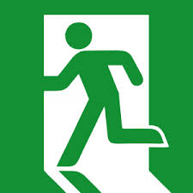
Evacuating a Building

The procedures listed below assist occupants during a building evacuation. Circumstances that may require building evacuation could include a fire or fire alarm activation, discovery of a suspicious object, an unexpected release of a hazardous material, or a verbal announcement or text message. Always remain calm and follow directions given by emergency responders (police or fire department personnel) or other designated public safety officials.
General Information
- Know the location of at least two exits from your area.
- If provided, be familiar with the evacuation routes shown on your building evacuation map for your floor.
- In any emergency situation, call 911
- Follow specific work unit instructions following an evacuation, such as work unit notifications or other procedures.
If evacuation is necessary, follow these procedures:
- Exit the building as calmly and quickly as possible using the nearest safe exit. Do not use the elevator.
- Direct others, including students in classrooms, and those in the immediate area to evacuate.
- Quickly shutdown operating equipment, if it is safe to do so.
- Gather your personal belongings, if it is safe to do so.
- If safe, close your office door(s), but do not lock them.
- Help others in need of assistance.
- Move to a safe location away from the building or to your Building Designated Meeting Site.
- Advise designated public safety officials if you suspect that someone is missing, injured or needs assistance to evacuate.
- Do not re-enter the building or work area until you have been instructed to do so by designated public safety officials. Silencing of alarms does not mean the emergency is over.
For questions or additional information contact your Safety Officer or Environmental Health and Safety at 814-865-6391.

