MS Teams Calling and 911 Emergency Location User Guide and Instructions
  - Document Number: EHS-0155 Version 1.0 Date Issued: 08/2024
  - Tier 2 Document – Penn State Community-based Programs and Services

Purpose

Penn State uses Microsoft Teams Phone (“TEAMS phone”) as the primary telephone service to enable users to make and receive phone calls external to the Penn State community. Refer to the Penn State Information Technology website for specific details. From a 911 emergency calling perspective, users need to establish their “emergency location” associated with their TEAMS phone to support 911 location identification.

Scope
Applies to individuals who are using TEAMS phones as their primary phone to potentially call 911 in an emergency situation.

Responsibilities
Penn State faculty, staff and students using TEAMS phones:
- Become familiar with this user guide scope and applicability.
- Follow the user guide instructions to identify your emergency location in TEAMS phone.
- Update this information as needed based on work location and potential use of TEAMS phone to call 911 in an emergency.

Definitions
911 Building Street Address — Penn State buildings have been provided formal building address as of March 2024. Refer to the Penn State LionSpace Facility Information System (FIS) to verify building addresses as needed. LionSpace FIS is accessible for all Penn Staters with user credentials.
TEAMS Phone Emergency Location — workplace location that individuals identify as their emergency location in the event of calling 911 from their TEAMS phone. This is currently a manual process for individuals that may choose to use a TEAMS phone to call 911 versus other means (e.g., cell phone).

Physical Phone Requirements - EHS

- **Phone used in the context of this guidance includes a handset device that provides immediate access to any user for emergency communications.

- All locations where hazardous materials (chemical, biological and radioactive hazards) are used or stored must have access to a physical phone to call out in an emergency. The phone must be within a reasonable distance from the location to permit timely emergency communication.
- The following locations must have direct and unimpeded (unobstructed) access to a physical phone. Direct and unimpeded means that the phone must be located within 55 feet of the area. One door can be present so long as it opens in the same direction of travel.
  - Areas where chemical waste is generated
  - Areas where toxic gases are used or stored,
  - Areas covered by process safety management
  - Areas covered by explosives management.
  - Areas as required by NRC or PADEP radioactive materials license.
  - Areas operating at Biosafety Level 3.
  - Areas with significant physical hazards such as medium and high hazard machine shops
  - Locations that do not have reliable cell or internet coverage including remote locations with poor cell phone and internet coverage must have access to a physical phone to call out in an emergency. The phone must be within a reasonable distance from the location to permit timely emergency communication.
- Large event spaces – refer to Emergency Management.

Other Exclusions
Not part of initial phase of project:
Building systems (elevators, fire alarm panels, detection devices, etc.)
Emergency blue phones and wall phones

Getting Started
Laptop is enabled to share the location with Teams? This should help with the issue:

https://support.microsoft.com/en-us/office/enable-location-sharing-583dd649-87fc-4b23-aed6-f4e2279297f9

Identifying Penn State Building Addresses
The Office of Physical Plant maintains LionSpace Facility Information System (FIS) for various building information purposes. Specific to this procedure, it also serves as the repository for building 911 addresses that also serve as the mailing address. Refer to the following instructions to look up your building addresses in LionSpace FIS.
- Login to LionSpace FIS (https://lionspacefis.psu.edu/invision/) using your Penn State credentials.
- Click on “Campus Viewer”.
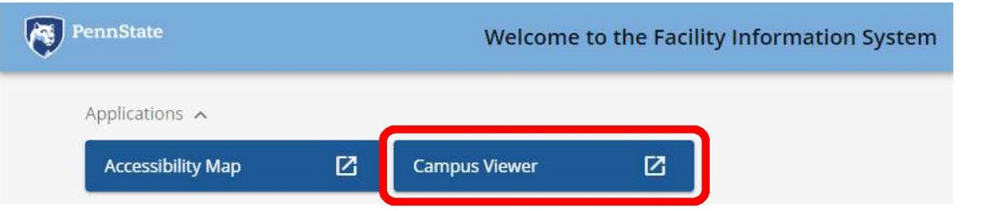
- Search and Select your desired building.
- Scroll down to see the building address.
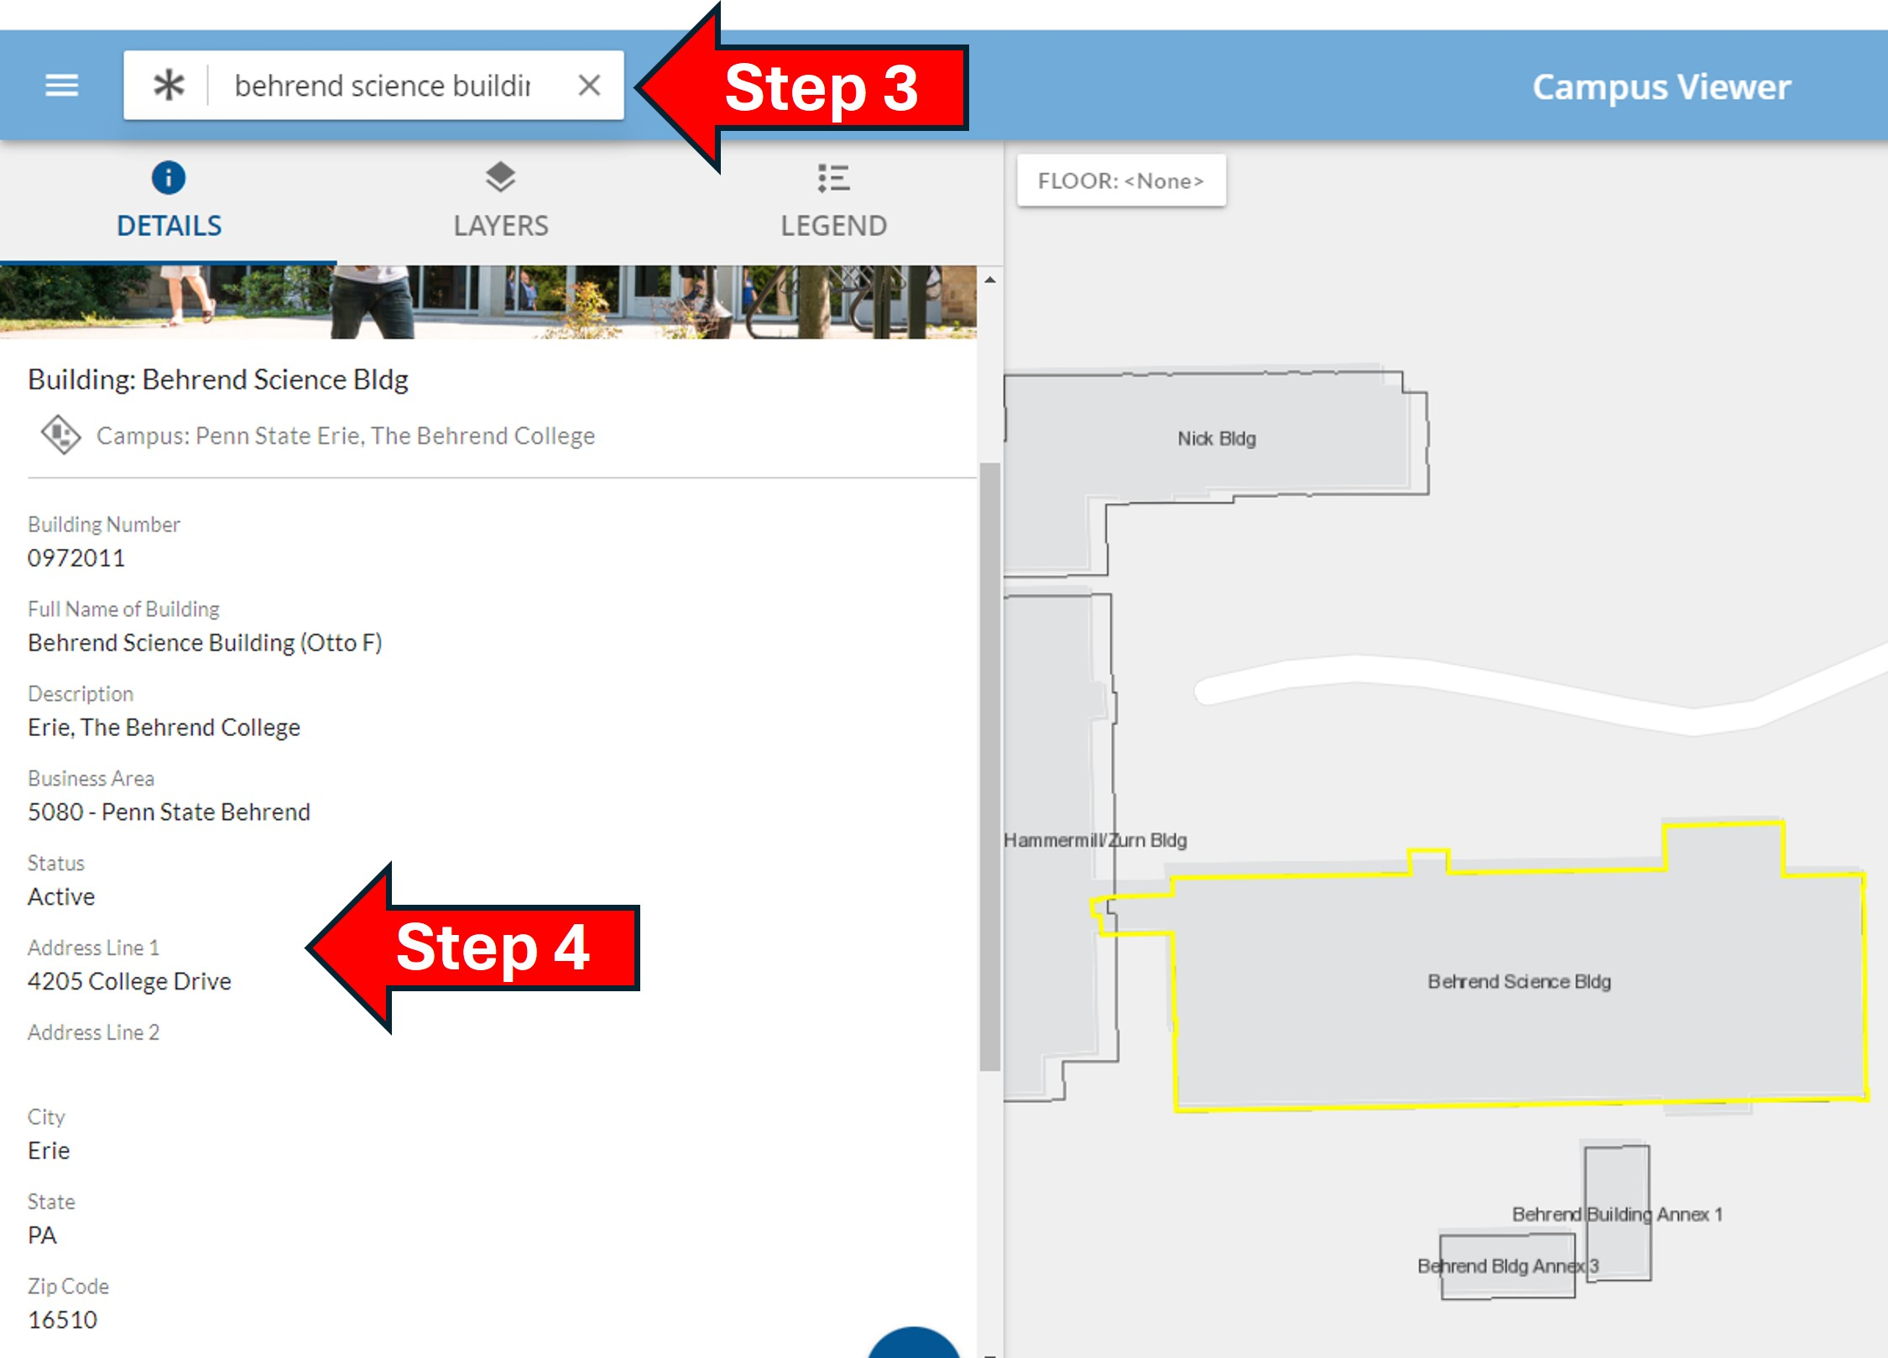

Update Emergency Location in TEAMS Phone
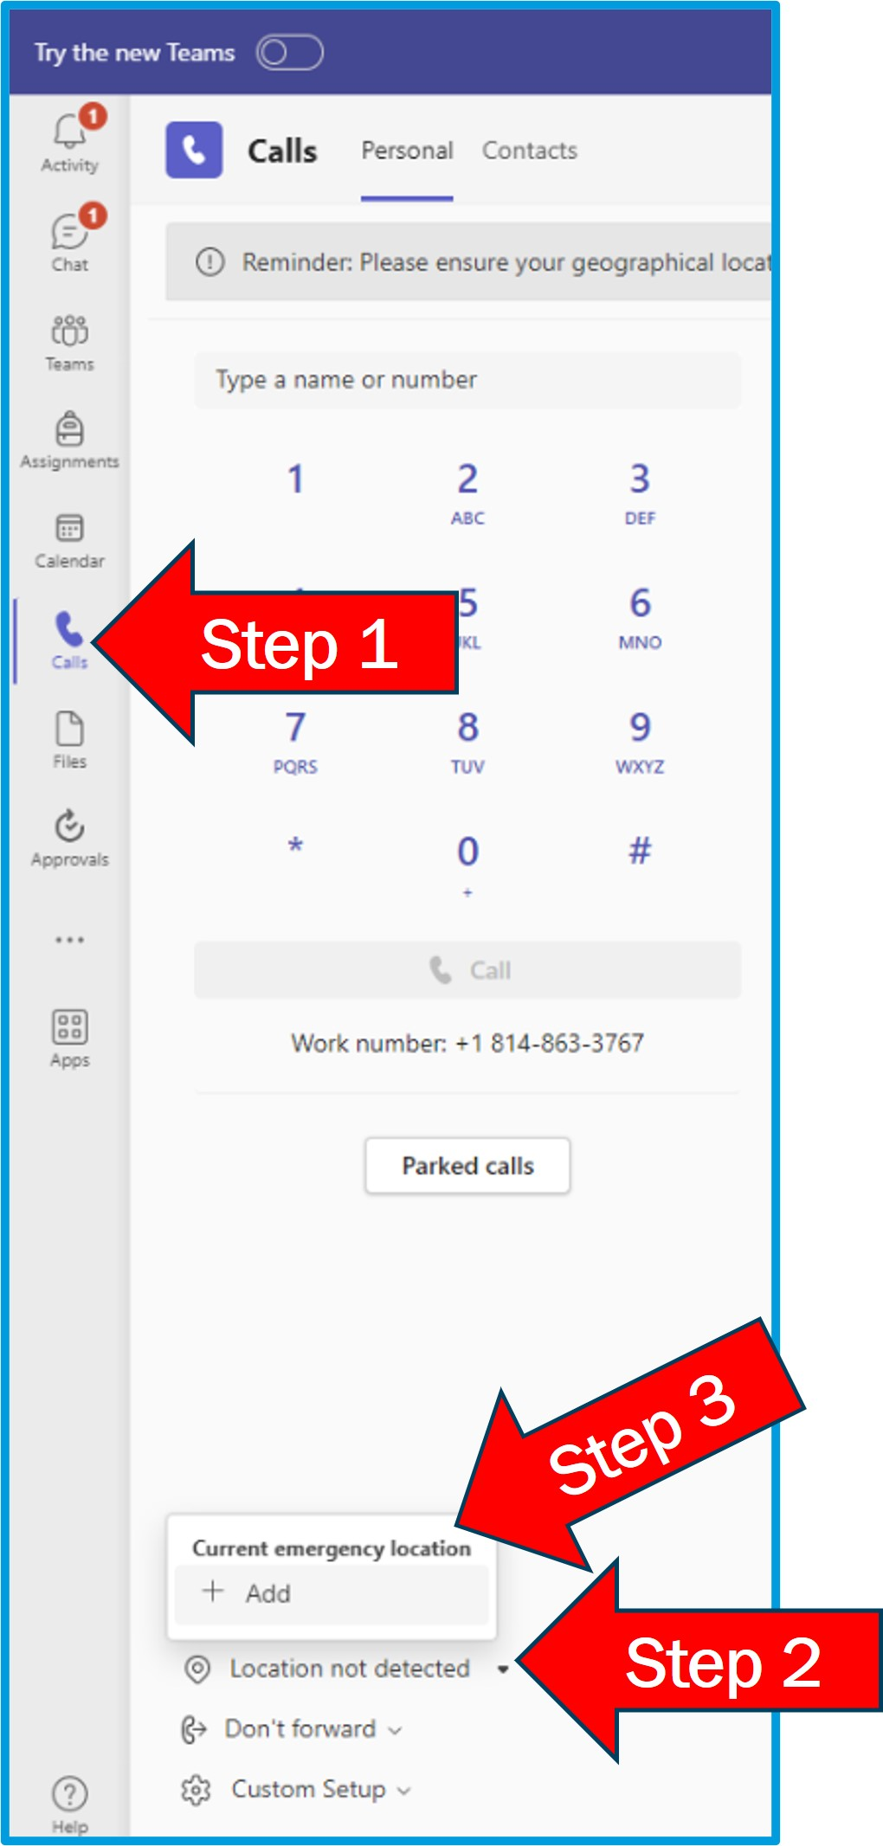
The following instructions are provided to update your emergency location in TEAMS in the event you use TEAMS Phone for 911 emergency calls from your computer.
- Make sure laptop and/or mobile phone is enabled to share the location with Teams:
              - https://support.microsoft.com/en-us/office/enable-location-sharing-583dd649-87fc-4b23-aed6-f4e2279297f9
              - This process must be completed in order to retain the device location.
- Go to “Calls” within the Microsoft Teams App.
- Review location settings and select drop down “Location not detected”.
- “Current emergency location” window will pop-up and select “+ Add”.
- Select “Enter address manually”.
- Enter building street address details in “Manage your location” window.
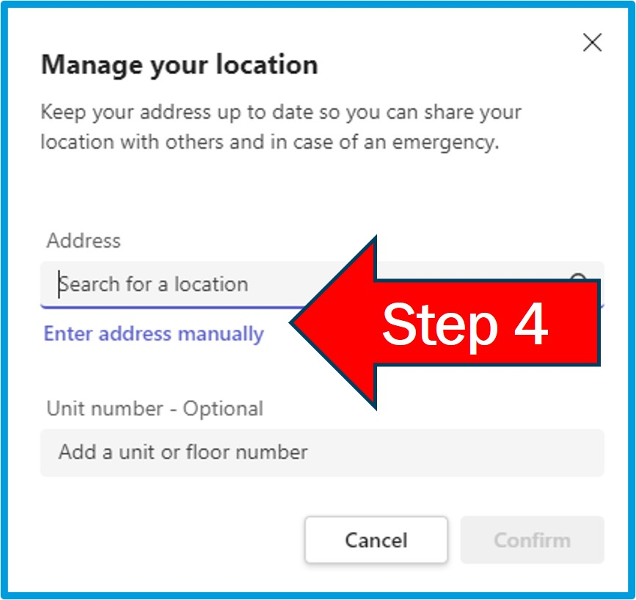
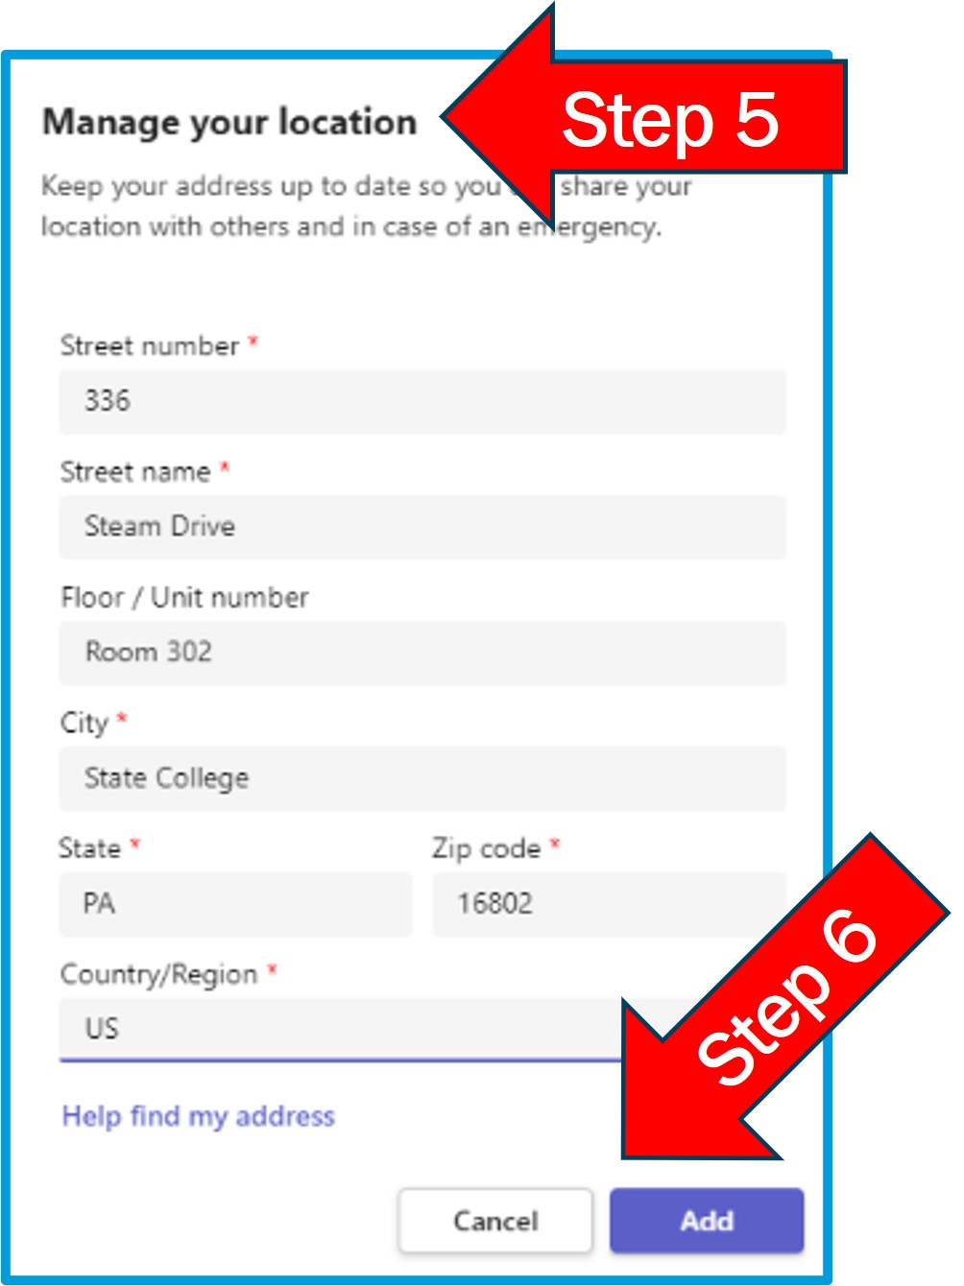
- Click “Add” to save emergency location information.

References
Penn State IT Teams Phone and Teams-to-Teams Calling
Penn State OPP LionSpace Faciliaties Information System (FIS)

