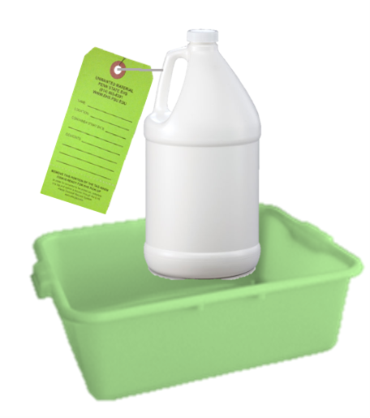

Document # EHS-ATC01 Rev: 04

**Submit a pickup request online at:**

**ehs.psu.edu/waste-disposal**

Chemical Spills in the SAA:

**STOP** the source of the spill

**CONTAIN** the spill

**CLEAN** up all small spills immediately using absorbent materials or universal spill pads

**CONTACT** EHS if replacement secondary containment is needed or to report a sizeable spill

Major Spills:

**EHS:** (814) 865-6391 (M-F 8-5)

**University Police:** (814) 863-1111 or 911 For Commonwealth Campuses

**CONTAINERS:**

- must be kept closed, with the exceptions of adding, removing or venting waste.

- should be segregated from other incompatible wastes.

**The satellite accumulation area (SAA) must be inspected weekly and containers may not exceed 12 months in the accumulation area. If the volume exceeds 55 gallons of unwanted material and/or 1 quart of the reactive acutely hazardous materials, contact EHS to arrange disposal.**

**Containers must have a waste tag that lists full contents and accumulation start date**

**Chemicals should never be drained disposed or intentionally evaporated!**

**Containers must be in good condition, with no cracks or leaks and stored in clean and compatible secondary containment**

**LABORATORY SATELLITE ACCUMULATION AREA**

**LOCATION: ______________________________________________________**

**PI: _____________________________________________________________**

**RESPONSIBLE PERSON: _____________________________________________**

**CONTACT NUMBER: ________________________________________________**