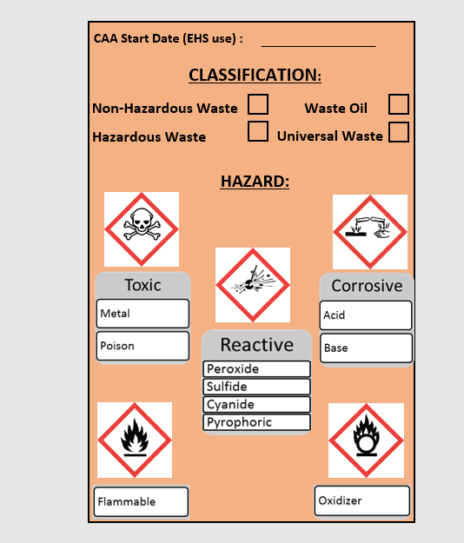

Rev 2- 4/26/24

Chemical Spills in the SAA:

**STOP** the source of the spill

**CONTAIN** the spill

**CLEAN** up all small spills immediately using absorbent materials or universal spill pads

**CONTACT** EHS if replacement secondary containment are needed or to report a sizeable spill

Major Spills:

**EHS:** (814) 865-6391 (M-F 8-5)

**University Police:** (814) 863-1111 or 911 For Commonwealth Campuses

**Submit a pickup request online at: ehs.psu.edu/waste-disposal**

**Chemicals should never be drained disposed or intentionally evaporated!**

CONTAINERS:

- must be kept closed, with the exceptions of adding, removing, or venting waste.

- must be in good condition (no cracks or leaks) and stored in secondary containment.

- should be segregated from other incompatible wastes

The total volume of all hazardous waste containers in the SAA should never exceed 55 gallons.

Submit a waste request online at [www.ehs.psu.edu](http://www.ehs.psu.edu) to have waste removed from the SAA.

Use the Waste Guidance Document to complete the waste determination on back of tag. **This must be done at the start of waste generation.**

If your item is not included on this chart, contact EHS at   
(814) 865-6391.

The satellite accumulation area must be inspected weekly. Containers must be labeled with a completed orange waste tag, including the waste determination section on the back of the tag.

**SPILLS**

**CONTAINER INFO**

**WASTE TAG**

**SATELLITE ACCUMULATION AREA**

**LOCATION: ______________________________________________________**

**RESPONSIBLE PERSON: _____________________________________________**

**CONTACT NUMBER: ________________________________________________**